University of Plymouth

School of Engineering, Computing and Mathematics

COMP3000

Final Year Computing Project

2024/2025

GuardPoint

David Penfold

10774418

BSc (Hons) Cyber Security

Project Supervisor: Rory Hopcraft

# Acknowledgements

I’d like to highlight my appreciation towards Rory Hopcraft, my project supervisor, for his continuous support and help in the development of GuardPoint. Rory has provided critical feedback per sprint and quick email responses throughout the development process and documentation. This has encouraged me to keep a high standard and stay punctual throughout the project. The final product would not have been achievable without his continuous guidance.

# Abstract

Cybersecurity threats are on the rise and cyber awareness lacks within many companies. This leads to heavy reputational and monetary damage. 50% of UK businesses faced cyber-attacks in 2024 compared to 32% in 2023 (Cyber security breaches survey, 2024). To help combat this problem I have developed GuardPoint.

GuardPoint is a web-based application which aims to fill the void of poor cyber security awareness within companies through interactive and gamified tasks. The primary objective of the project is to provide an educational interactive Cyber Security Training tool that any employee can complete regardless of technical ability.

GuardPoint also provides an admin dashboard where appropriate roles can track the progress of each employee and track the overall scores per their company.

Progress tracking is made possible with sign up and log in page functionality. The tasks are housed within a realistic desktop.

1. Phishing Identification allows users to interact with emails and gain knowledge on identifying phishing emails.
2. Password training teaches best practices when creating passwords and tests current passwords against real time data breaches.
3. Safe Web Browsing task educates users on dangerous results. This is done with a search engine powered by OpenAI. Additionally, the safe web browsing task offers a gamified learning experience.

# Table of Contents

Contents

Acknowledgements 2

Abstract 2

Table of Contents 3

Word Count 6

Code Link 6

Introduction 7

Background, Objectives and Deliverables 8

Background 8

Objectives 8

Deliverables 9

Literature Review 10

Interactive Approach, Learning and Theoretical Foundation 10

Learning Theories 11

Chosen Tasks 11

Methodology and Development 12

Design Justification 12

Inclusivity 12

ISO 27000 Compliance 12

Summary 12

Method of approach 13

Agile 13

Risk Assessment 13

Technologies 14

Requirements 15

User Stories 15

Functional Requirements 15

Non-Functional Requirements 16

Minimum Viable Product Requirements 16

Design 17

Low-Fidelity Prototype 17

Design Principles 17

Architecture 18

Database Design 18

ERD Diagram 19

API Route table 20

Flow Charts 20

Legal, Social, Ethical and Professional Issues 22

Legal Issues 22

General Data Protection Regulation 22

Licensing 22

Socials Issues 23

Technical Ability 23

Training Fatigue 23

Ethical Issues 23

Consent 23

Transparency of AI use 23

Professional Issues 23

Professional Standard 23

Duty of Care 23

Project management 24

Trello 24

Version Control 25

Supervisor Meetings 25

Time Management 26

Development 27

Phase 0: Project Initiation (Sprint 0) 27

Phase 1: Scoping and Early Design (Sprints 1–2) 27

Phase 2: Email Task Development and Password Task Early Design (Sprints 3–4) 27

Phase 3: Project Flow, Password Task Redesign and Web Development (Sprint 5) 28

Phase 4: OpenAI Integration, File Reconstruction and Additional Features (Sprint 6) 28

Phase 5: Database Coding, Improved Design and Admin Preparation (Sprint 7) 29

Phase 6: Web Task Development, Quiz Development and Admin Dashboard Research (Sprints 8-9) 29

Phase 7: User Feedback and Admin Dashboard Implementation (Sprint 10) 30

Phase 8: Web Task Gamification, Final Polishing, User Testing, and Reporting (Sprint 11) 30

Implementation 32

Software Engineering Principles 32

MongoDB Atlas 32

API Usage 32

Have I been Pwned (HIBP) 32

OpenAI 33

Sign Up 33

Login 35

Desktop 35

Profile 37

Phishing Identification 38

Password Creation 39

Safe Web Browsing 40

Quiz 42

Admin Dashboard 43

Table of Features 44

Testing 44

Unit Testing 44

Integration Testing 45

User Testing 45

End-Project Report 47

Summary 47

Project Changes 47

Objective Review 47

Provide an educational interactive Cyber Security Training tool that any employee can complete regardless of technical ability. 47

Provide a quiz to test new learnt knowledge. 47

Provide a functional sign up and log in system with progress tracking to keep progress between sessions. 48

Provide an admin dashboard for tracking and resetting of employee progress. 48

Provide interactive tasks, not just information on a screen. 48

Allow user information to be edited and deleted. 48

Post-Mortem 49

Objectives Evaluation 49

Developer Evaluation 49

Project Management Evaluation 49

Technologies Evaluation 49

What Went Well 50

What Could Have Gone Better 51

Future Work 52

Conclusions 52

Reference List and Bibliography 53

Appendices 55

Appendix 1: User Guide 55

Appendix 2: API Route Table 56

Appendix 3: User Stories 57

Appendix 4: Integration Test Table 58

Appendix 5: Privacy Policy 59

Appendix 6: Terms and Conditions 60

Appendix 7: User Feedback Questions 60

Appendix 8: User Feedback Answers 64

Appendix 9: File Structure 68

Appendix 10: MVP Feature Table 69

Appendix 11: Feature Table 70

Appendix 12: ISO 27002 Task Alignment 71

Appendix 13: ISO 27000 Series GuardPoint Compliance 71

Appendix 14: Risk Assessment 72

# Word Count

Words – 10,988

# Code Link

GitHub: <https://github.com/DPenf0ld/COMP3000>

# Introduction

Poor Cyber Security Awareness is the leading factor of monetary loss and security breaches within companies. A 2023 systematic review focused on SMEs revealed that limited literacy is the root cause of both awareness and resource constraint issues (Carlos Rombaldo, 2023). 50% of all UK businesses have faced cyber-attacks in 2024, compared to 32% in 2023. In addition, on average only 18% of businesses have had training or awareness raising sessions in the last 12 months (Cyber Security Breaches Survey, 2024). Training levels are low, yet cyber-attacks are increasing.

The solution to combat this growing problem is to employ appropriate staff training throughout the company. Many organisations rely on annual cybersecurity awareness training to meet compliance requirements. Majority of which provide static videos with limited feedback – to users and admins. Training, when not reinforced regularly, fails to significantly reduce security risks or prepare employees for evolving cyber threats (Julie Haney, 2021).

GuardPoint, the solution, aims to redefine user training. GuardPoint is a web-based application provided to fill the void of poor cyber security awareness within companies. Offering interactive and gamified tasks which increases employee engagement and therefore retention. The primary objective is to provide an educational interactive Cyber Security Training tool that any employee can complete regardless of technical ability.

There are three tasks involved with GuardPoint. These have been carefully selected based on the biggest threats within Cyber Security. Therefore, a phishing identification task, password creation task and safe web browsing task have all been implemented (more information in deliverables). Each of these include critical information on how to better practices. The tasks have been made on an interactive basis which aims to improve user retention. After completion of all tasks users can undertake the quiz.

The other aspect of GuardPoint is an admin dashboard. This is designed for appropriate roles in the organisation to track their employee progress and results. The admin dashboard provides reset buttons and a graph view for better visualisation.

The following report will detail the background research that identified the need for GuardPoint, outline the objectives and deliverables, provide the chosen methodology and list requirements. Followed is information on Design and Architecture, LSEP considerations and the project management process. Next, includes discussion of development and implementation. Concluding with testing, evaluations and reflections on the software development lifecycle and the future development of GuardPoint.

# Background, Objectives and Deliverables

## Background

Cybersecurity awareness training platforms are widely available; however, many fall short in terms of user engagement, accessibility and inclusivity. GuardPoint aims to improve upon traditional training by offering a dynamic and gamified experience which all technical levels can complete. Platforms such as KnowBe4, Google’s Phishing Quiz and SANS Security Awareness provide training modules or simulations but are often passive or text heavy.

GuardPoint is set apart due to its interactive desktop environment, real-time AI integration used in email generation and web content and an admin dashboard for progress tracking. Due to GuardPoint’s hands-on learning approach long term behavioural change and better information retention is aimed to be achieved. This is critical when combating human targeted cyber threats.

Market research confirms the need for such innovation. Phishing clicking rates have tripled in 2024 despite user training (CSO, 2024). Yet only 18% of businesses report providing regular training (Cyber Security Breaches Survey, 2024). GuardPoint is positioned to bridge this gap by delivering training that is engaging, personalised and efficient.

## Objectives

* Provide an educational interactive Cyber Security Training tool that any employee can complete regardless of technical ability.
* Provide a quiz to test new learnt knowledge.
* Provide a functional sign up and log in system with progress tracking to keep progress between sessions.
* Provide an admin dashboard for tracking and resetting of employee progress.
* Provide interactive tasks, not just information on a screen.
* Allow user information to be edited and deleted.

## Deliverables

A functional web-based application that has three interactive tasks which teach cyber security awareness - designed based on gaps identified in literature review.

**Phishing Identification** – Users are placed in a virtual inbox, they must highlight suspicious words of each email and select the type of email they believe it is (type of phishing or a safe email). OpenAI is used to generate additional emails after completion of preloaded emails.

**Password Creation** – Users use the API ‘Have I been pwned’ (HIBP) to check if their passwords have appeared in any data breaches. Users must then create a new password using NCSC guidelines. The password input box changes colour based on strength. After successfully creating a new password, users must check to see if it has appeared in a breach.

**Safe Web Browsing** – A simulated search engine is provided using OpenAI. Results are tailored to the search and realistic. The user gains feedback about whether each article is safe or not and why. The game is available after receiving feedback on each article. The game provides search results randomly placed around the screen, the user must select as many safe articles as possible within 30 seconds. Score is increased per correct selection and deducted per incorrect selection.

**Quiz -** 15 questions based on the knowledge taught and learnt in the three tasks. Passing mark of 70% must be achieved to complete GuardPoint. Incorrect answers trigger a reset of related task.

**Admin Dashboard - A**dmins can check the organisational quiz average and reset user tasks/quiz. A graph view is available to visualise organisational results.

# Literature Review

Research has been conducted into some of the current cyber security training solutions (Figure 1) to identify gaps in engagement, accessibility and effectiveness. This helps identify what is missing and helps figure out which aspects of a successful training platform works.

|  |  |  |  |
| --- | --- | --- | --- |
| **Training** | **Summary** | **Level** | **Interactive** |
| KnowBe4 | Industry Standard platform. Offers phishing simulations and awareness training. Focus on video modules, quizzes and email campaigns. | Intermediate | Moderate |
| Cyber Aware (UK Gov) | Provides basic cybersecurity guidance. Focus on security via strong passwords and device safety. | Beginner | No |
| Google Phishing Quiz | Practice in identifying phishing emails by red flags with an interactive quiz. | Beginner | Yes |
| SANS Security Awareness | Training split into modules with phishing simulations. Focus on continuous learning. | All Levels | Moderate |
| Infosec IQ | Offers gamified activities such as phishing tests and behaviour tracking. Training tailored to employee role. | Intermediate | Yes |
| Cisco Security Training | Extensive PDF and video-based content. Focus on corporate compliance. | Intermediate | Low |
| Cybersecurity Lab (PBS) | Very game centred. Focus on privacy, social engineering and password cracking. | Beginner | High |
| IBM Security Learning Academy | Heavy reading mate rials and pre-recorded videos. Range of topics. | All Levels | Low |

Figure 1 – Current Cybersecurity Solutions

This comparison reveals that while some platforms include gamified and interactive tasks, the majority still rely on static content (videos or PDFs). Most of the training does not cover all user levels.

## Interactive Approach, Learning and Theoretical Foundation

GuardPoint provides an interactive learning approach unlike traditional training platforms such as Cisco Security or IBM Security which use static content. This interactive approach has been adoptive due to trends in current cybersecurity training that emphasize the need for gamified and simulated environment – such as in Cybersecurity Lab (PBS). Academic literature has shown how active participation and immediate feedback result in better retention and behavioural change (Prümmer, 2023). This relates to how active learning is one of the most effective ways to retain knowledge and develop skills. Furthermore, with the use of gamified elements - when implemented transparently - engagement and learning outcomes are significantly boosted (O'Brien, 2025). GuardPoint integrates gamification in its safe web browsing task, encouraging users to actively engage. Ultimately, GuardPoint makes learning more engaging and accessible for users with lower technical ability with the use of immediate feedback.

Interactive learning has become present in many sectors such as aviation. Extended realty flight simulators are used to train pilots by placing them in an immersive environment which has proved to enhance decision-making, reduce errors, and increase retention (Ross & Gilbey, 2023). Other simulations such as military training and diving, use immediate feedback and active learning, showing improved engagement and retention – rather than passive methods (Duffy & Jonassen, 1992). Similarly, GuardPoint applies interactions in all tasks - providing a simulated inbox for phishing identification and web simulations to teach users how to identify suspicious links. This allows users to practice skills that mimic real-world cybersecurity.

## Learning Theories

**Constructivism** – proposed by scholars such as Jean Piaget and Lev Vygotsky, suggests that learners build understanding with active experiences. GuardPoint has considered this by providing users real-world scenarios. Therefore, encouraging problem solving and active learning.

**Experiential Learning** – David Kolb (1984), highlights importance of learning through reflection. Furthermore, GuardPoint’s tasks are all feedback driven which gives users a chance to reflect on their actions and improve them.

## Chosen Tasks

**Phishing Identification:** Phishing is an essential area due it being the most common cyberattack vector. Phishing click rates have tripled in 2024 despite user training (Lucian Constantin - CSO, 2024). Humans remain the biggest vulnerability within Cyber Security. Users often fall for deceptive emails, especially without the necessary training. Studies show that phishing susceptibility remains high, however training can reduce vulnerability (Krombholz, 2015). The study highlights the need for continuous reinforcement in training programs.

**Password Creation:** Password security remains weak within cyber security. The UK’s National Cyber Security Centre (NCSC) has found that many people use easily guessable passwords despite guidance (Coker via InfoSecurity, 2023). Research explores why users persist in using weak passwords despite available guidance (Woods & Siponen, 2024). Results reveal psychological factors such as cognitive overload, habit formation and perceived difficulty of password creation. GuardPoint’s Password Creation task addresses these challenges by helping users create passwords, test old passwords, understand risks and adopt secure habits.

**Web Browsing:** Online web browsing is a daily activity, involving users accessing links and sources. Many users struggle to distinguish between legitimate and malicious websites. These can redirect to variety of dangerous attacks. Research highlights how attackers exploit victims by using techniques like typosquatting and combosquatting to make phishing websites appear legitimate (Zieni, 2021). New phishing URLs are created daily to avoid detection - importance of web browsing training is essential. GuardPoint uses simulated results to educate users on recognising suspicious links and unsafe websites.

After completion of all tasks, the quiz is available. The quiz will reset tasks depending on incorrect questions amount per task category. This supports the "test and reinforce" model seen in effective training systems (KnowBe4 and Infosec IQ). The admin dashboard allows tracking of progress and results. This helps managers monitor cybersecurity awareness over time, supporting sustained ISMS compliance and promoting accountability.

## Methodology and Development

GuardPoint has been built with an Agile methodology, incorporating continuous feedback and user testing. This allows constant improvements. This aligns with software development approaches for responsive, user-centred design – incorporating user feedback (Beyer and Holtzblatt, 2004).

## Design Justification

The usability and visual design significantly affect the effectiveness of security training (Terronova Security, 2023). Best practices have been applied to GuardPoint:

* Simple colour schemes with high contrast.
* Clear instructions with minimal jargon (specialist terminology).
* Interactive elements that mimic real-world decision-making.

GuardPoint adopts a clean, accessible design using soft colours, easy navigation and clear instructions. Interactive elements mimic real-world decisions in the phishing identification task and safe web browsing task.

## Inclusivity

As seen in the previous table, a recurring issue is that the training is too simple or too hard and rarely for all levels. Research shows training effectiveness correlates to users technical ability in many cases (Nelson and Cheney, 1987).

GuardPoint is designed with universal usability in mind:

* Tasks that all can complete.
* Simplified language.
* Supportive feedback.

This ensures inclusivity and fosters confidence among all users, not just IT professionals.

## ISO 27000 Compliance

Task selection and design are based on industry trends, academic literature and support ISO 27001 and ISO 27002 compliance. ISO 27001 requires regular cybersecurity training as part of an effective Information Security Management System (ISMS). GuardPoint helps meet these requirements by offering knowledge tests and an admin dashboard to monitor user progress.

Detailed mappings of task alignment with ISO 27002 controls and GuardPoint’s compliance features are provided in Appendix 12 and Appendix 13.

## Summary

There are many cybersecurity training platforms, however most fall short in engagement, accessibility, and interactivity. GuardPoint looks to fill these gaps by offering an interactive, user-friendly and inclusive learning environment. Both academic and industry recommendations are followed. The chosen tasks are carefully picked and directly support ISO 27000 series with the goal of improving user behaviour.

# Method of approach

## Agile

The agile approach was adopted during the development of GuardPoint. This helped break the project down into small manageable sections. The focus was delivering functional software at the end of each sprint with continuous improvements. This was an effective development method but also helped with staying on top of workload and not falling behind during development.

An advantage of agile is its flexibility, due to requirements and plans being constantly evaluated per sprint. Integration of new features and adjustments can be aligned easily to the timeline, without having to start from scratch. This was made clear when the decision to narrow down the proposed tasks built into GuardPoint changed from five less detailed tasks to three polished tasks.

A limitation while using agile was not having a predefined ending point. Since agile adopts planning per sprint it made it hard to scope a true realistic ending point. This coursed impacts of imbalances of time spent creating each task within GuardPoint.

Other alternatives to the agile approach include the Waterfall model. This is a sequential project management methodology where each phase is completed before the next one begins. This method provides clear deadlines and upfront planning but lacks the flexibility to adopt changing requirements throughout the project.

Another option is the Spiral model, combining iterative development with risk management. Included is a spiral of phases, each focusing on planning, risk analysis, engineering and evaluation - repeating until the project's goals are met. This model does offer a better way to mitigate risk regularly however is much too complex for a project of GuardPoint’s scale. Ultimately, agile was chosen due to its adaptability, iteration and suitability to incorporate feedback throughout the development lifecycle.

## Risk Assessment

Agile requires risk assessments to be constantly monitored. An initial risk assessment was created to identify major risks, in addition to risks identified bi-weekly in line with sprints. New risks identified per sprints were added to the risk plan to help with future development. The risk assessment allows risks to be visualised and plan mitigation when necessary. The full risk assessment, including the risk score matrix, identified risks, current controls and planned mitigations, can be found in Appendix 14.

## Technologies

## 

|  |  |
| --- | --- |
| **Technology** | **Purpose/ Usage** |
| **Visual Studio Code** | Perfect for building and debugging web applications. Supports the necessary framework of .NET. Allows extensions such as ‘Live Server’ for quick development. Includes an integrated terminal to run NPM commands and install necessary packages. Provides a window to view old git commits and therefore can easily compare versions to highlight any problems without reverting to an old commit completely. |
| **JavaScript** | Primary language used across the full stack – frontend and backend. Used due to asynchronous and event driven nature – perfect for GuardPoint. Previous experience within JavaScript allowed for a strong foundation, therefore less time spent on learning and more time on enforcing best code practices. Client side – JavaScript drives interaction within tasks due to event listeners and dynamic DOM manipulation. Server side – JavaScript is used within Node.js and Express.js to manage APIs, handle authentication and interact with MongoDB Atlas. |
| **Node.js** | Used to enable development with JavaScript due to efficiency and ability to handle asynchronous operations. Node.js works with Express.js to manage routes, API calls and middleware functions. Node.js makes communication with MongoDB possible and its architecture allows multiple operations to run at once –fetching user data or validating passwords without slowing down the system.  Packages used in Node.js include jsonwebtoken, dotenv, bcryptjs and openai. Used to implement features such as authentication, password hashing and AI-generated emails and web searches.  Vitest and supertest (used in unit testing) are both supported ensuring reliability of backend logic and API endpoints. Overall, Node.js has provided a foundation for building, maintaining and testing GuardPoint. |
| **Express.js** | Built on top of Node.js, Express.js provides the web framework used in GuardPoint. Express.js covers routing, middleware and HTTP request handling. Its purpose is to connect the frontend to backend services – server-side logic is created and RESTful API endpoints.  Examples include defined routes for user registration, login and progress tracking. Middleware allows for operations such as verifying JSON Web Tokens for authentication and enabling Cross-Origin Resource Sharing (CORS) for secure frontend-backend communication.  Express supports modular JavaScript by allowing logic to be spread across multiple files – more organised codebase. |

# Requirements

### User Stories

User Stories (Appendix 3) were created at the start of the project and used to derive requirements for the project.

### Functional Requirements

**User Registration:**

* Users can sign up by entering their details and organisation.
* Users can log in with their created credentials

**Learning & Progress:**

* Users must receive feedback throughout each task to reinforce learning outcomes.
* Users must be able to view their progress and quiz scores, including between sessions.
* Users must complete a quiz which assesses knowledge gained throughout the platform.
* The quiz must track the mark per question group and reset appropriate task if pass mark is not achieved - ensures continued learning.

**Training Outcomes:**

* The user leaves the training with new and useful knowledge on cyber security.
* The user can use what they have learned in real world situations.
* The user understands how to create strong, secure passwords and why it matters.
* The user becomes more aware of how to evaluate the safety of websites and links.
* The user gains confidence in identifying phishing attempts.

**Phishing Identification:**

* Users can identify the email type by selecting a tick box.
* Users can highlight suspicious words and gain feedback if they’re correct, incorrect or missed words.
* Email generation must be unique after example emails are complete, powered by OpenAI for realism and variety.

**Password Creation:**

* Users can test their current password to check strength.
* Users can use the ‘Have I been pwned’ API to check if their password has been in a data breach.
* Password creation must follow NCSC guidelines.

**Safe Web Browsing:**

* Users can identify dangerous links and gain feedback about the link.
* Users must receive unique results based on their web input.
* Users can access a gamified mode to test their web safety knowledge under time pressure.

**Admin Access:**

* Admins can view their organisation average.
* Admins can view task progress and quiz results per user.
* Admins can view a graph interface for better visualisation.
* Admins can reset individual user tasks or quizzes.

### Non-Functional Requirements

**Performance:**

* The application should load within 2 seconds of logging in.
* Email AI generation should be done in the background to avoid wait times.

**Security:**

* User data should be encrypted in transit and at rest to protect against unauthorised access.
* No passwords should be stored.
* All passwords must be hashed when sending to APIs and database.

**Usability:**

* The desktop should have an easy flow to follow and understand.
* The user’s interface should be intuitive and easy to navigate.
* There should be clear instructions and feedback per task.

**Compliance:**

* GuardPoint should comply with applicable laws such as GDPR.
* GuardPoint should follow ISO 27001- requirements for establishing, implementing and maintaining an effective information security management system (ISMS).
* GuardPoint should follow ISO 27002 - best-practice controls for information security, including user awareness training, secure data handling, and access control.

### Minimum Viable Product Requirements

MVP was kept in mind during early development of GuardPoint. This is a crucial aspect of all projects. MVP is the state the project must be in to achieve basic functionality with enough features to see the scope of the project. All necessary requirements were identified to achieve MVP with a deadline set. The deadline was the return of Christmas break (first sprint back - 07/01/25). From here the table of requirements was derived to make this goal possible, the MVP table can be viewed in Appendix 10. A full feature table, achieved at the end of the project, is in Appendix 11.

# Design

## Low-Fidelity Prototype

Figma, an interface design application, was used to develop low-fidelity prototypes. Offering drag and drop functionality, Figma allowed for quick creation of a basic interface for GuardPoint (Figure 2). During development it was identified how it would be best to house the tasks in a virtual desktop and make the transition of a realistic interface.

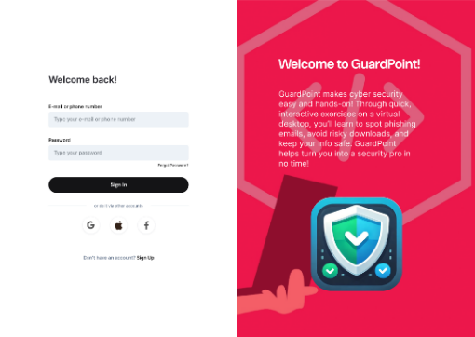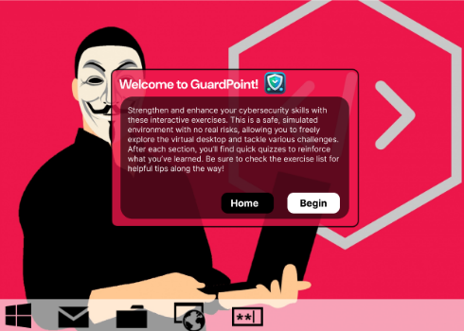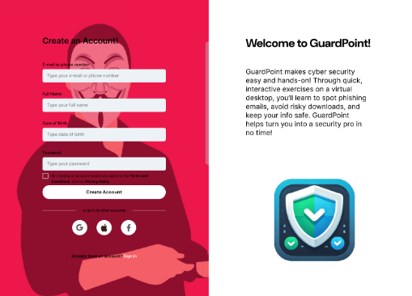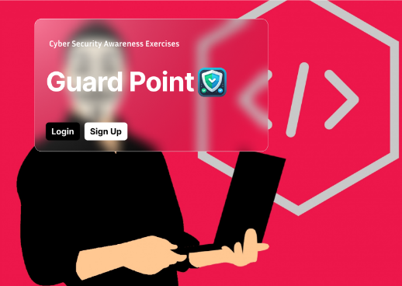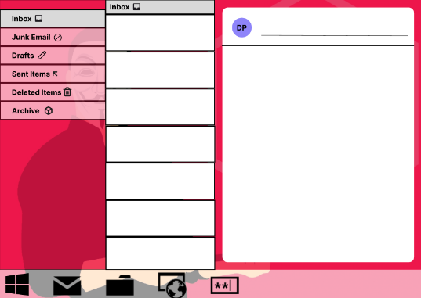A basic landing page, sign up and login page were created. The home desktop with a progress tracker and taskbar was developed. In addition, the basic planning of the inbox was created – due to this task having to be as realistic as possible and being the required task for the MVP.

Figure 2 – Figma Basic Interfaces

## Design Principles

The following design principles helped shaped GuardPoint:

* User-Centric Design: Tasks are housed in a desktop to help create a typical employee scenario. Furthermore, the inbox and web are aimed to give a realistic feel. This helps users relate to real world daily activities.
* Clarity and Simplicity: UI with soft colours, large icons (which change to ticks once completed) and instructions per task.
* Consistency: Navigation elements (desktop icons, taskbar, progress tracker) all have the same look and functionality for an easy user experience – multiple options to get to the same place – just like a real desktop.
* Feedback First: All user interactions return immediate feedback – correct email type, correct highlighted words within inbox, password strength, password breach amount, web search safety.
* Accessibility: Tasks include a familiar desktop design with large icons and text.

This ensured GuardPoint remained intuitive, engaging and inclusive through development.

# Architecture

## Database Design

MongoDB has been the chosen as the database for GuardPoint - justification under MongoDB heading. All user information is stored in a single user’s collection with passwords hashed using bcrypt.

MongoDB stores data in a JSON like documents with only required fields. Furthermore, the schema is dynamic which means new fields can be added without schema migration. This is key during agile development due to the continuous iteration in the software development lifecycle. Additionally, in future development further tracking for new modules can easily be added.

Each user document uses nested objects (all of which are assigned on creation). These are used to store the status of tasks and quiz results. The purpose of this design is to group related user data in a logical and modular way.

Accessing task states is easy in the backend since the tasks and quizscores objects are returned as part of the user data upon login, allowing direct checks (Figure 3), without additional queries or processing.

Users are assigned an ObjectId upon creation, however MongoDB allows for efficient indexing on specific fields, therefore fast lookup during login and admin operations can be achieved with user emails.

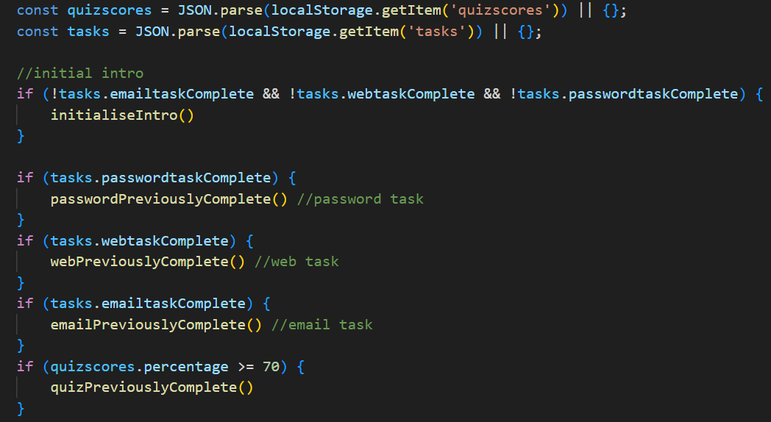

Figure 3 – Direct User Data Checks

## ERD Diagram

Figure 4 shows an ERD diagram for the MongoDB database. Due to MongoDB being a NoSQL, document-based database – the ERD relationships are simplified. All user information is stored within a single user document, including embedded objects. Figure 5 shares a snippet of how user information is stored in MongoDB. Figure 6 shares the code logic of admin filtering and gathering user’s data for the admin dashboard.

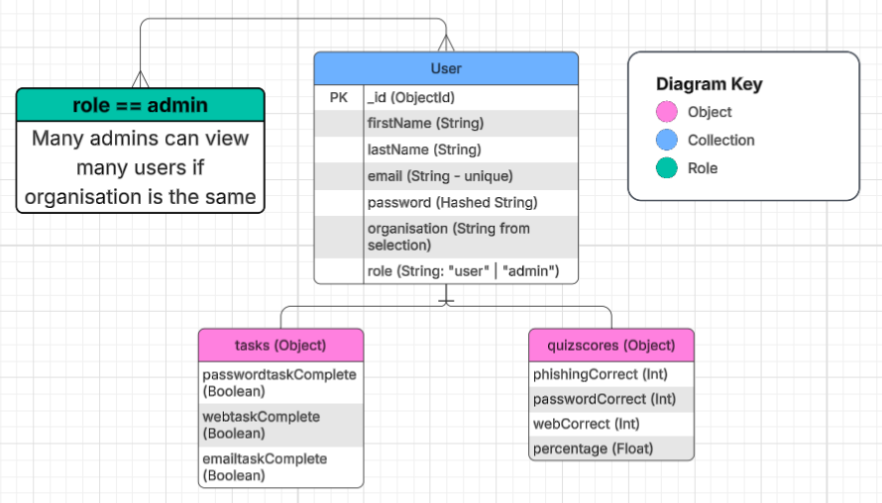

Figure 4 – MongoDB ERD Diagram

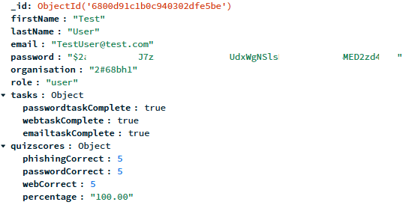

*Password Hash Hidden*

Figure 5 – User information in MongoDB

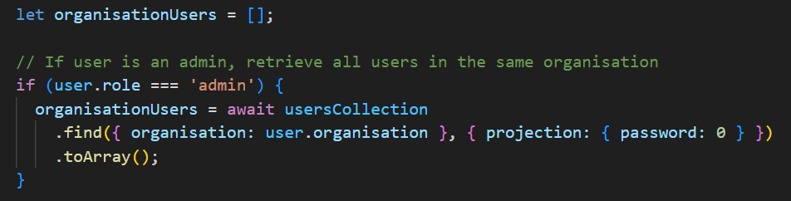

Figure 6 – Admin Filtering

## API Route table

RESTful endpoints outline the core backend routes to support GuardPoint’s functionality. They allow for secure communication between the frontend and backend. Data validation, error handling and JWT authentication have been applied where appropriate to ensure robustness and secure processes. The full API Route table can be found in Appendix 2.

## Flow Charts

The following charts demonstrate some of the logic used within GuardPoint which have helped map out logic implementation. Figure 7 shares logic of opening tasks and Figure 8 shares login logic.

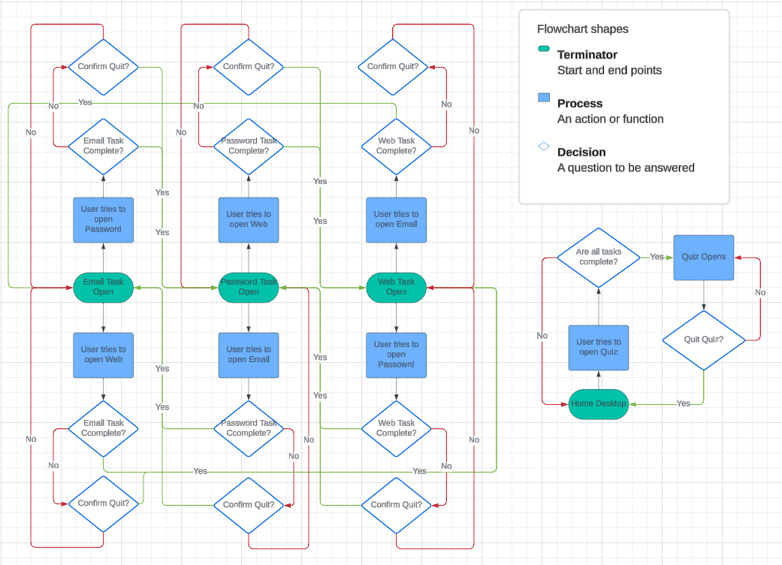

Figure 7 – Opening Task Logic

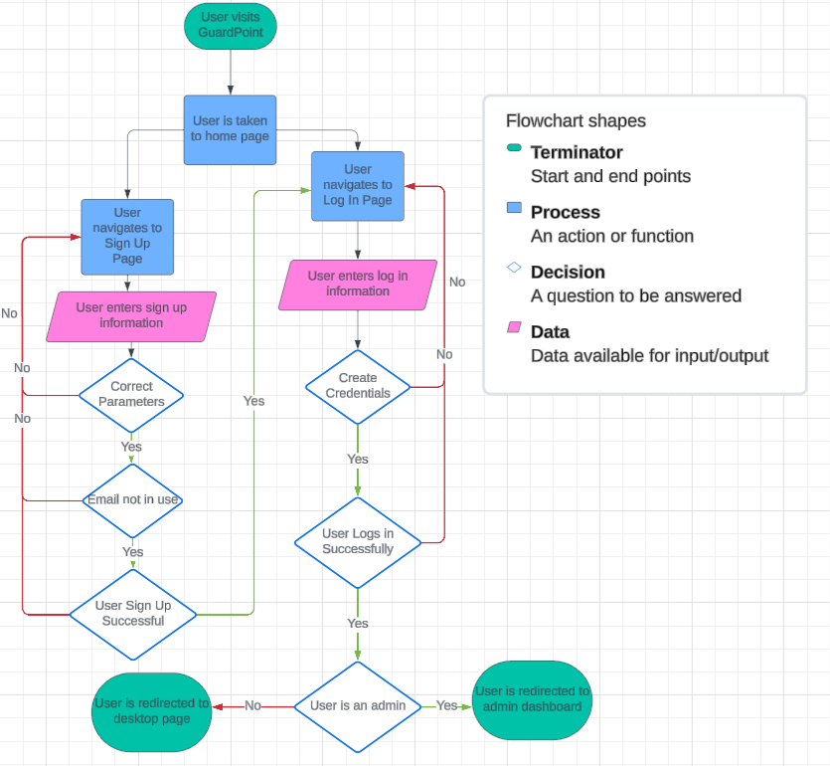

Figure 8 – Login Logic

# Legal, Social, Ethical and Professional Issues

## Legal Issues

### General Data Protection Regulation

General Data Protection Regulation (GDPR) applies to all EU organisations and therefore was closely followed during development of GuardPoint. GDPR is a harmonised set of rules applicable to all personal data processed by organisations. This includes how data is stored, protected and processed.

GuardPoint aligns with GDPR by only collecting essential data and data is used exclusively for cybersecurity awareness training.Early versions of GuardPoint required unnecessary data in the sign-up page such as date of birth. This has been removed to comply with GDPR principle of data minimisation.

Privacy enhancements have been made by changing the organisation drop down option within sign-up to a code (provided by the organisation owner to employees) rather than a full company name. In the future this will be changed so that the user must enter their code instead of a drop down. This prevents visibility of participating organisations to outside users.

During sign-up users must agree to the privacy policy and terms and condition policy which can be viewed and must be ticked for a successful sign-up. The privacy policy contains the following information:

* What data is being collected.
* Why the data is being collected.
* Who can access the data.
* How long the data is being stored for.

Full privacy policy and terms and conditions policy can be viewed in appendix 5 and 6.

A key privacy feature, within the admin dashboard, is that admins can only view user information in their own organisation. Passwords are never displayed and always hashed for protection.

Users can also access and manage their own in information via their profile once logged in. They can edit information or even delete their account, supporting the GDPR rights of access, correction and deletion.

### Licensing

During development licensing has been carefully reviewed and understood to have correct permissions. GuardPoint uses a combination of third-party tools, each with their own licencing terms.

MongoDB (data storage) operates under the Server Side Public License (SSPL) which is not violated since GuardPoint is not currently being offered as a service to others. In the future if GuardPoint was deployed companies would run it internally and not as a hosted platform to avoid violations.

The ‘Have I Been Pwned’ API is used under fair use for educational purposes and OpenAI’s API has been integrated with OpenAI’s Terms of use policy in mind. All third-party tools are used responsibly and are in line with licensing agreements.

## Socials Issues

### Technical Ability

Not all users will have the same technical ability when it comes to completing GuardPoint, organisations are made up of various ages and backgrounds. If GuardPoint was made too technical some users may feel embarrassed or left behind if they struggle with the tasks. GuardPoint has been made for all technical abilities and tested. Additions have been added such as animated arrows and a progress tracker to help further.

### Training Fatigue

Users are expected to complete GuardPoint within one sitting with an estimated completion time of 30 minutes. Therefore, tasks have been kept simple, and information is concise. Alternatively, if GuardPoint requires long periods of time or tasks are not clear this can lead to fatigue. This can result in users not fully taking on board information and training becoming ineffective. Task progress is also sent to MongoDB, therefore if necessary, users can take a break and resume training later.

## Ethical Issues

### Consent

It must be made clear to the user what data is being collected and why. This relates back to the privacy policy which the user must read and consent to before signing up to GuardPoint.

### Transparency of AI use

Users are informed that they are interacting with AI and furthermore the AI limitations. Examples of this is in the phishing identification task. Users must first complete the premade emails which fit the criteria from a training point of view before trying AI generated emails.

## Professional Issues

### Professional Standard

Best standards must be upheld during development of GuardPoint. These include secure coding practices, maintaining user privacy, alignment with GDPR and following relevant ethical standards.

Thorough testing has been conducted to reduce bugs and vulnerabilities, password hashing has been adopted to protect user data. Clear documentation is aligned with all the development process and include reflection to reach a professional standard.

### Duty of Care

As a developer of GuardPoint I must deliver a duty of care to users. This includes ensuring that GuardPoint is safe, secure and beneficial to users. This relates to not only technical coding and security but also providing relevant and accurate cyber security guidance.

# Project management

## Trello

Trello is an online tool which helps organise a project into a board which identifies what is being worked on (Trello, 2017). The use of Trello allowed multiple tasks to be organised and managed effectively (Figure 9). The following categories were created:

* To do
* Work In progress
* Completed

Each of these were created for the following categories - Phishing, Password, Web, Desktop, Quiz, Admin Dashboard, Others. Therefore, this created a total of 21 lists to track work effectively. This also doubled up as a product backlog to track what had been completed and offered a place to store user stories. Ultimately, Trello helped manage multiple tasks and led to great organisation during the development of GuardPoint.

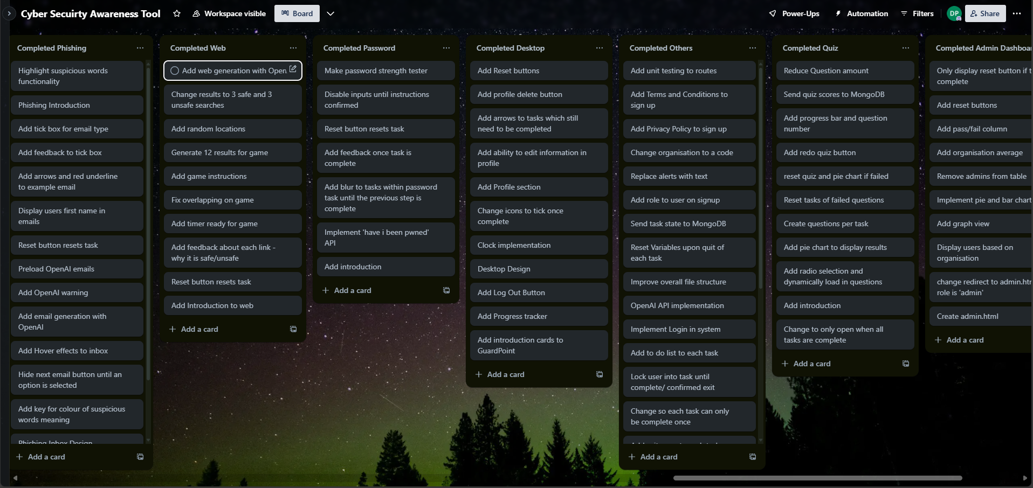

Figure 9 – Trello Completed Cards

## Version Control

Version control was essential throughout GuardPoint due to the scale of the project and continuous changes. GitHub allowed for complete version control and security against any potential data losses. In a few scenarios code had to be rolled back to an old version, or an old commit had to be reviewed to find what caused a new error. Commits stayed constant throughout the project and in addition over 300 commits were made (Figure 10).

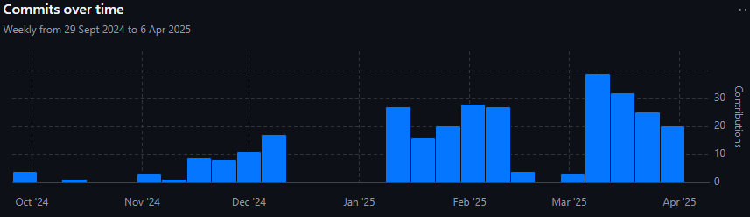

Figure 10 – GitHub Commits

## Supervisor Meetings

Bi-weekly supervisor meetings were held throughout the project. This helped form sprints and demonstrate work that had been completed. These proven very useful for meaningful feedback from not only my supervisor but other members in the same supervisor group to help improve GuardPoint.

## Time Management

Time management is critical in any project to ensure on track delivery. As identified in the risk assessment, time management creep could potentially be a big vulnerability. To mitigate the risk, many techniques were used to allow GuardPoint to stay on track and employ effective time management.

One of the primary tools used was a Gannt Chart, created at the start of the project (Figure 11) and updated throughout the project when necessary. Figure 12 shares the final Gannt Chart version. For example, a major choice within development was to reduce the number of tasks to three core tasks. Therefore, it was important to amend the Gannt Chart appropriately.

The use of sprints also helped break up the workload into manageable phases. This approach made it easier to monitor progress and adjust priorities when needed.

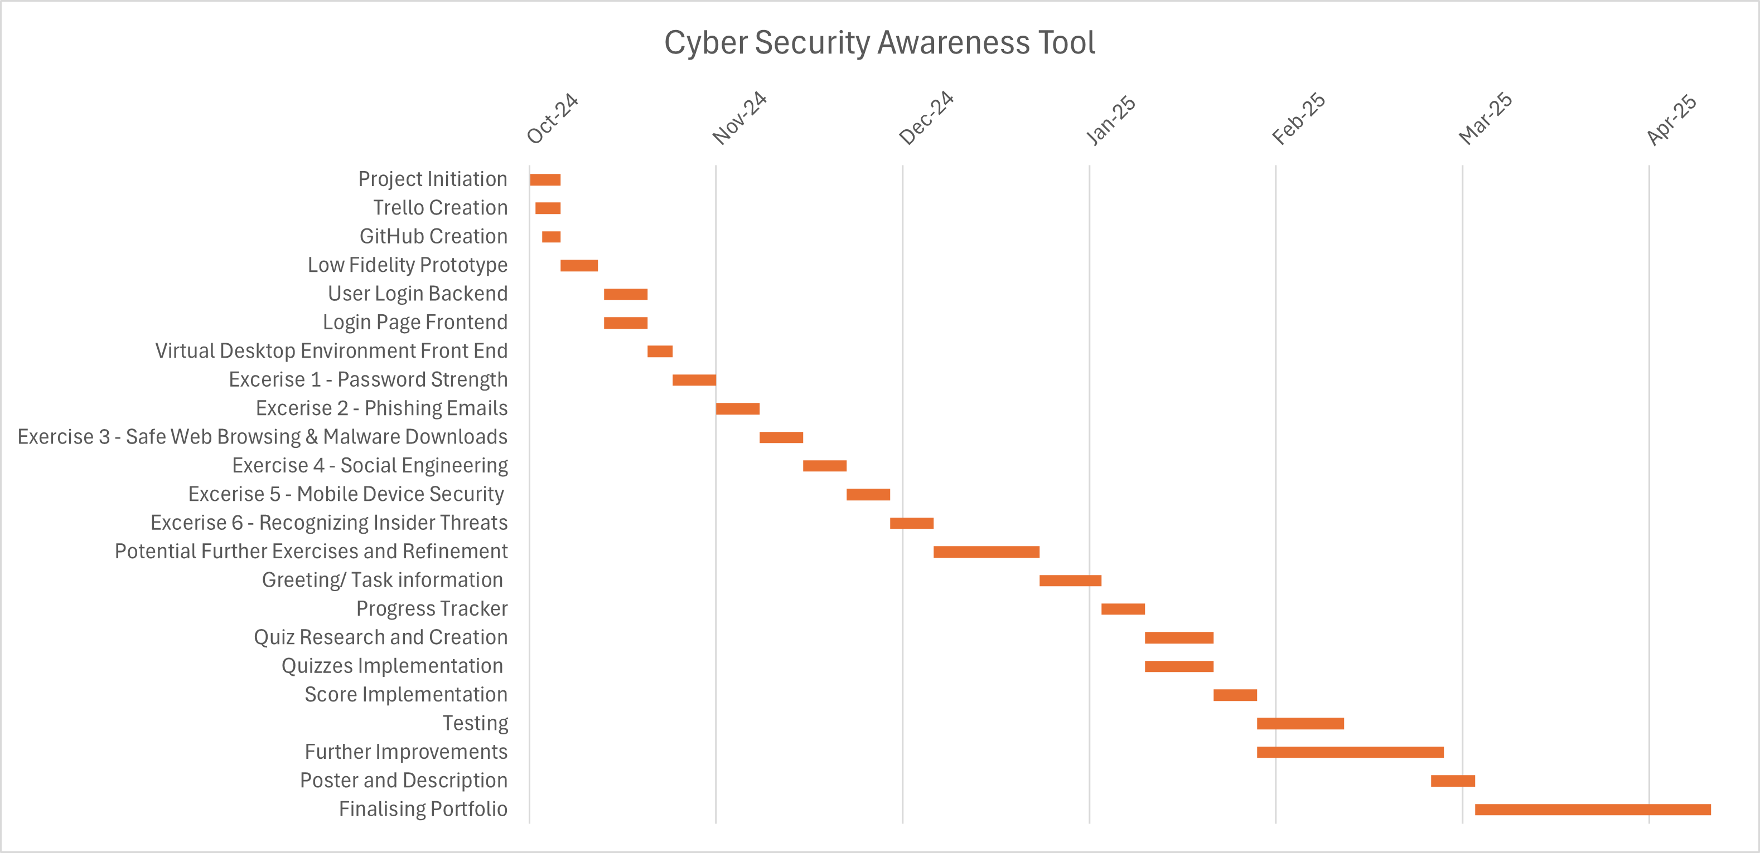

Figure 11 – Initial Gannt Chart

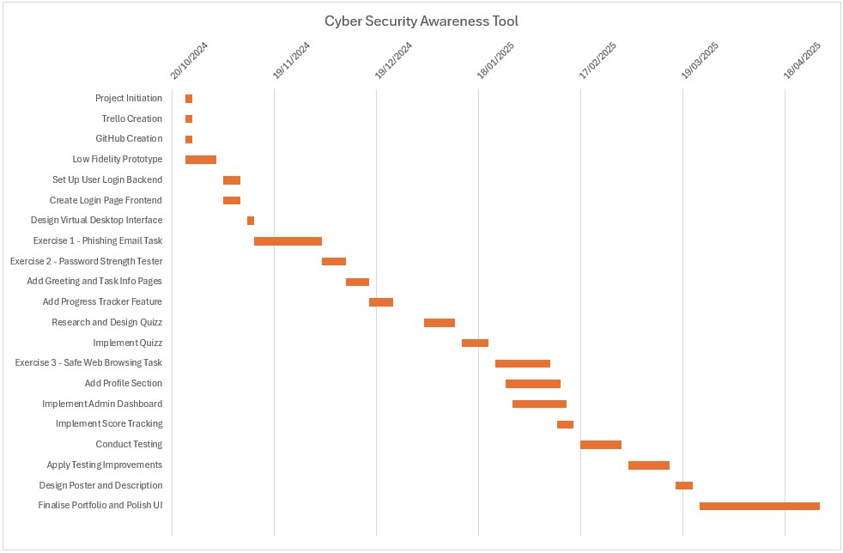

Figure 12 – Final Gannt Chart

# Development

## Phase 0: Project Initiation (Sprint 0)

Date: Start of academic year

Narrowed down premise of the project after a brief conversation with supervisor in the first lecturer of the year. Early scoping to determine the cybersecurity training focus. Research into other training materials online was investigated and work began on looking into which tasks would be included in training.

## Phase 1: Scoping and Early Design (Sprints 1–2)

Date: 29/10/24 – 26/11/24

* Low-fidelity prototype developed with Figma. User stories created to help prototyping by deriving requirements – both functional and non-functional.
* Established GitHub repository and Trello Board for task tracking.
* Developed signup/login system which connects to MongoDB with password hashing and signup parameters.
* Began tracking task status with MongoDB.
* Decision made to narrow down tasks to just 3 instead of the initial proposal of 6. Updated documentation accordingly (Gannt Chart update, information planned per task, Requirements and User Stories).

## Phase 2: Email Task Development and Password Task Early Design (Sprints 3–4)

Date: 26/11/24 – 07/01/25

* Further styling on login and signup pages. Uploaded Screenshots of current progress to GitHub.
* Conducted research into phishing techniques – contacted University of Plymouth’s phishing team to get real-world examples but was unsuccessful.
* Developed highlighting functionality for suspicious words. Highlighted words are checked against a predefined list once email type is submitted – words are then colour coded to reveal if they are suspicious, safe or missed.
* Developed hover effects to reveal link addresses. Hover effects given on links and profile picture to reveal true sources - encouraging users to use better cyber practices.
* Designed first example phishing email with step-by-step instructions (including pointing arrows at different parts of the email).
* Added email type reminder and basic tick box to submit email type. Correct answer is given on submit and user is informed if they were correct.
* Planned and began the Password Task, following NCSC password guidelines.
* Added toggle ability for password task – reused email task logic.
* Creation of password strength tester – colour changing depending on amount of IF statements met – such as IF contains an uppercase etc.
* Time spent researching how to implement an external API into GuardPoint.
* Integration of "Have I Been Pwned" API to give feedback about if a password has appeared in a data breach and how many times.

## Phase 3: Project Flow, Password Task Redesign and Web Development (Sprint 5)

Date: 07/01/25 – 21/01/25

* Refinements made to Gannt Chart to match current progress and plan for the rest of the project.
* Further developed example phishing email based on user feedback – added arrows and red underlines.
* Implemented progress tracker on desktop to help project flow – includes icons changing to ticks when completed.
* Developed code to lock users in a task until it is completed – improve flow.
* Blurred background and disabled buttons while any instructions are present.
* Tidied up password task layout and added opening instructions.
* Added Web Toggle functionality – reused code.
* Implemented OpenAI API, based on previous knowledge API knowledge. Worked on generating web results based on the user’s input with the AI.

## Phase 4: OpenAI Integration, File Reconstruction and Additional Features (Sprint 6)

Date: 21/01/25 – 04/02/25

* Integrated OpenAI into email inbox to generate emails after preloaded emails are complete. Efficient implementation since array was already created for storing emails and OpenAI has been previously integrated into the web task.
* Improved email OpenAI prompt to include ‘suspicious words’ from a predefined list for highlight functionality to work correctly.
* Restructured the whole project code for future development. Included splitting main JavaScript file over multiple files (controllers) and using ES modules, full file structure can be found in appendix 9. This allowed for more effective development and scalability.
* New features added such as logout button and ability to quit tasks (which resets all variables and intro slides).
* Added welcome cards to web task.

## Phase 5: Database Coding, Improved Design and Admin Preparation (Sprint 7)

Date: 04/02/25 – 18/02/25

* Database coding included working on storing task status – successful implementation allows user to log out without losing progress.
* Profile section created – displays user information.
* Edit profile ability.
* Reset buttons within profile section (only visible if the task is complete). Reset functionality calls the same functions as quit task previously implemented. Additionally, database task status is updated upon reset.
* Improved design – GuardPoint Icon, styles, colour schemes.
* Improved instructions per task.
* Preloaded emails upon login to avoid wait times with OpenAI email generation and added users first name to prompt to gain better results with safe emails and spear phishing emails.
* Planned logistics for admin dashboard – including adding organisation to sign up and automatically applying the role of ‘user’ when creating an account. ‘Admin’ role is manual assigned to specific accounts.
* Created a new basic Admin HTML where admins are redirected to once logged in (instead of the desktop).

Phase 6: Web Task Development, Quiz Development and Admin Dashboard Research (Sprints 8-9)  
Date: 18/02/25 – 18/03/25

* Web searches changed to provide 3 safe and 3 unsafe results. Results change colour to signify safety and feedback given about why the link is safe/unsafe upon click.
* Changed all alerts to text feedback and further improvements of styles across the project.
* Quiz Icon implemented to each appropriate location – reused toggle logic with additional locks – can only be opened once all tasks are completed.
* Developed quiz – intro slides added, and radio selection created. Worked on dynamically loading in each question and options each time an answer is submitted.
* Created questions based on the knowledge taught in each task. Started with a total of 30 and added a progress bar.
* Implemented results page once questions had been completed – provided text feedback on tasks passed and how many questions were correct. Included average percentage and total. Added pie chart for better visual of strengths (shows how many questions were correct per category – email, web and password).
* Quiz resets correlating task if a mark of 7 or less (out of 10) was achieved in any task’s questions. A re-do button is displayed the result page of failed task’s questions for quick access.
* Investigated a new AI on hugging face for cost-effectiveness but decided to retain OpenAI for reliability and new AI model requiring a reconstruction. Worth changing for future scalability.
* Further research on how to successfully display users progress and quiz results in the admin dashboard based on their organisation.

## Phase 7: User Feedback and Admin Dashboard Implementation (Sprint 10)

Date: 18/03/25 – 01/04/25

* Feedback took onboard from supervisor and peers in meeting group from live presentation. Included increasing size of icons and text, changing colours of certain elements (better readability), removing data of birth (no reason to require this), decreased quiz question amount (now 15) and added redo quiz button, changed organisation name to a code (GDPR).
* Further flow improvements - added Desktop intro cards (only for first time login) and animated arrows to desktop which points to tasks to be completed (removed once completed). Implemented end cards to each task.
* Developed quiz results sending to the database (including marks per category).
* Successfully implemented admin dashboard to display users progress and quiz results per admin’s organisation. Information includes task status, quiz marks and pass/fail category. Added filters to not display admins in table.
* Added organisational average (excluding users yet to take the quiz) and graph view which includes a bar chart (including a line for the average and a line for the pass mark) and pie chart for better visualisation.
* Developed admin ability to reset tasks/quiz (reset only appears if task/quiz is complete).

## Phase 8: Web Task Gamification, Final Polishing, User Testing, and Reporting (Sprint 11)

Date: 01/04/25 – 18/04/25

* Creation of web timer, score system, ‘random’ result placing and removing result once clicked.
* User must select which results are safe to earn points. The position of the web searches is predefined but do have a lenience to move which gives the ‘random’ feel but still stops any major overlapping.
* Score system implemented – points awarded for safe links and deducted for unsafe links.
* Shared logic used as normal web search to change the search red or green depending on safety.
* Added privacy and terms and conditions policies.
* Finalised all intro/end cards.
* Added pop up to signify the use of OpenAI.
* Improved preloaded emails by including current date.
* Added ability for the user to change their password and delete their account to comply with GDPR.
* Added unit testing for all routes with the use of Vitest.
* Creation of user questions for user testing.
* Carried out user testing among house mates and students – technical and non- technical.
* Remaining time was spent on finishing documentation.

# Implementation

## Software Engineering Principles

To ensure a scalable and maintainable product, best software engineering principles were applied:

* **Don’t Repeat Yourself (DRY)** – Code was reused with modular controllers (Appendix 9) and set into functions.
* **You Ain’t Gonna Need It (YAGNI)** – Features were only implemented as required. A good example is how additional AI models were postponed due to it not being essential at the time.

**SOLID Principles:**

* Single Responsibility: Each module had a clear purpose and aligned with their controller.
* Open/Closed: Code was designed to be extendable, new tasks can easily be added using a new Controller.
* Liskov Substitution and Interface Segregation: Logical separation and fallback behaviours ensured modularity.
* Dependency Inversion: App.js acted as a high-level module to which imported controllers (low-level) relied on. A problem within a controller would not affect the rest of the code.

These principles enhanced code clarity, enabled iteration and supported future scalability of GuardPoint.

## MongoDB Atlas

MongoDB Atlas is the fully managed cloud version of MongoDB. It is a NoSQL database built with scalability and flexibility in mind. Instead of traditional rows and columns, atlas uses documents which are grouped in collections.

Atlas handles the setup, scaling, backups, monitoring, and security making it perfect for a project like GuardPoint. Its quick set up offers all the features of a self-hosted database without the maintenance and still provides scalability.

Specifically, for GuardPoint, atlas offers powerful querying at good speeds which is ideal for the admin dashboard – making it easy to fetch all the appropriate data of all users in the same organisation, track their progress and reset tasks - effectively and quickly.

## API Usage

### Have I been Pwned (HIBP)

HIBP API allows users to check if their passwords have been exposed in a known data breach and therefore helps raise cyber awareness. This API has no limit of usage and is a free service. The password task makes use of this API giving an interactive experience. User passwords are hashed and never stored.

### OpenAI

OpenAI’s model of gpt-3.5-turbo and gpt-4 is made use in this project. Gpt-4 is used for phishing email creation and results have been perfected with a complex prompt. The purpose is to give unique results and demonstrate the capabilities of AI in the context of phishing.

Gpt-3.5-turbo is used to simulate web results based on the user’s prompt, therefore providing results tailored to the user’s input. Gpt-3.5-turbo is quicker than gpt-4 but is not as advanced. This is why gpt-4 has been used for complex email generation (loading done in the background), while gpt-3.5-turbo has been used for quick, yet more simple, real time web responses.

Unfortunately, both services are subject to restrictions due to the requirements of credits (via monetary deposits) in an OpenAI account, which of course can run out. Other free AI models have been investigated for future development (via hugging face) – check phase 6.

## Sign Up

The Sign-Up page (Figure 13) allows account creation to enable progression saves. Only necessary fields are required when signing up. Only valid sign-ups are allowed due to parameters in place – empty fields, passwords not matching criteria, invalid email, non-consent to policies. Users can toggle password visibility during sign up. Duplicate email addresses are not allowed. Full policy information can be viewed upon click (Figure 14 and 15). Both covers what is being consented to and how the data is used.

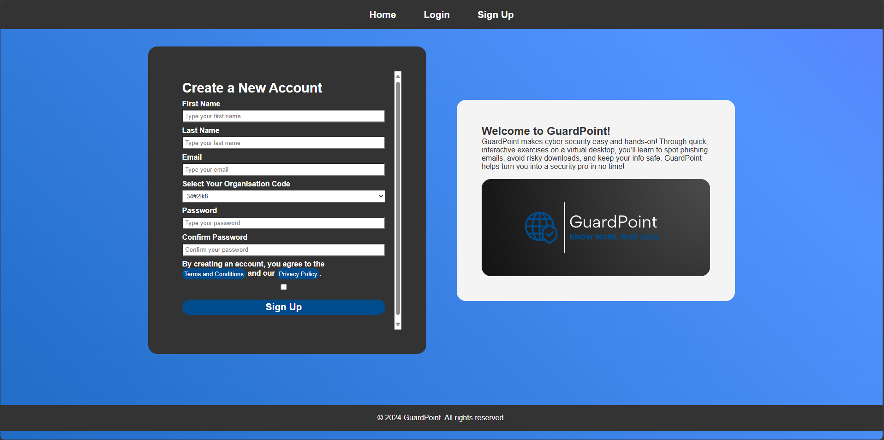

Figure 13 – Sign Up Page

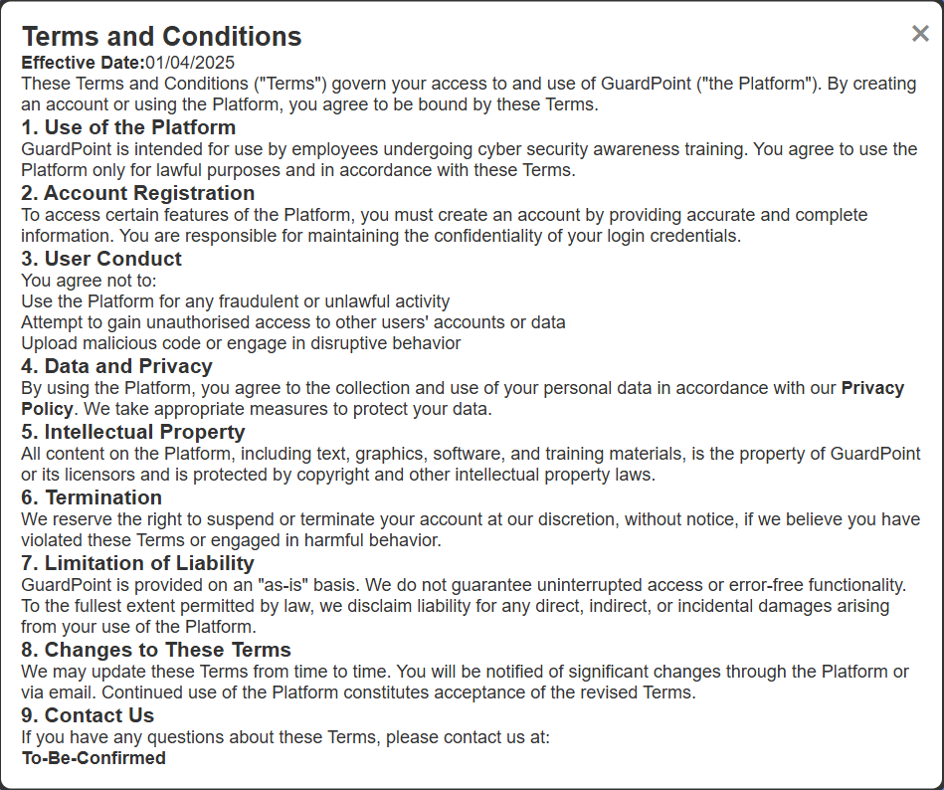

Figure 14 – Terms and Conditions

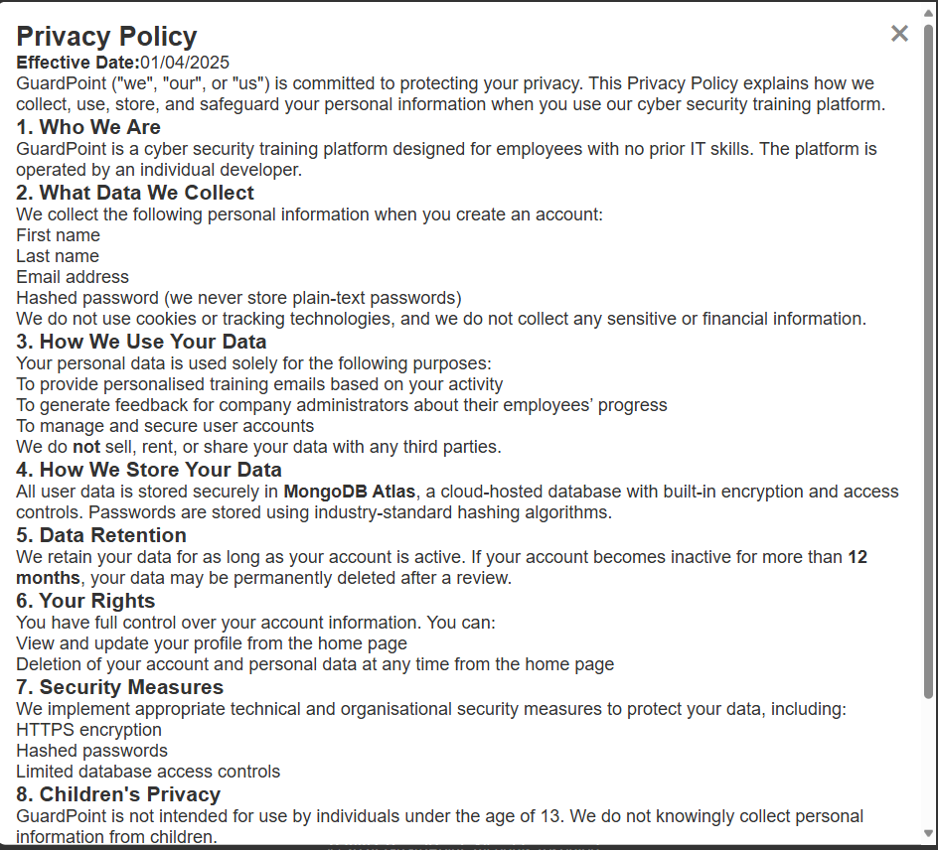

Figure 15 – Privacy Policy

## Login

The login page (Figure 16) redirects the user to the desktop if correct credentials have been entered, again the user can toggle password visibility. The login will redirect the user to the admin dashboard if the user has the role ‘admin’ which must be manually assigned (organisations will provide an email(s) address which they want set to admin).

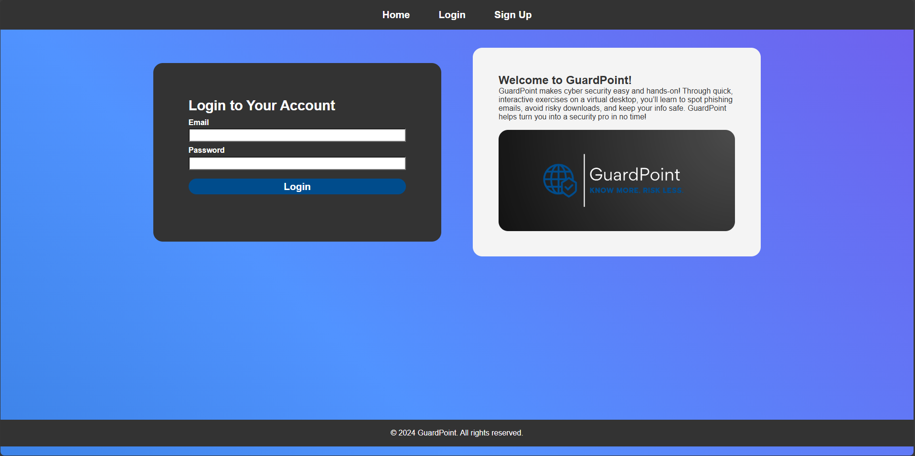

Figure 16 – Login Page

## Desktop

If the user hasn’t completed any tasks (or first time logging in) the introduction slides will be present (Figure 17). All desktop buttons are disabled during these slides. Icons per task are located on the taskbar, desktop and progress list. All of which direct the user to the correlating task. Users are locked into a task until it is complete (other icons cannot be accessed) – there is an option to quit but this will reset the task. An end card will appear to signify when the task has been complete. The user can choose to leave the task or carry on practicing their skills. The quiz task cannot be accessed unless all tasks are complete.

After introduction slides, animated arrows on the desktop point to tasks on the desktop which need to be completed. If a task is complete, the correlating arrow will be removed. Any completed task icons will be changed to have a tick overlay (Figure 18).

Users email is displayed in the bottom left of the taskbar – this is used to access the profile.

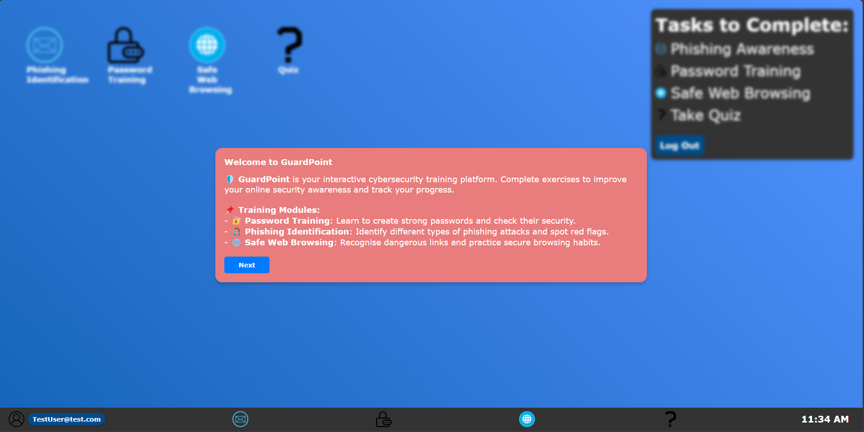

Figure 17 – Initial Desktop Instructions

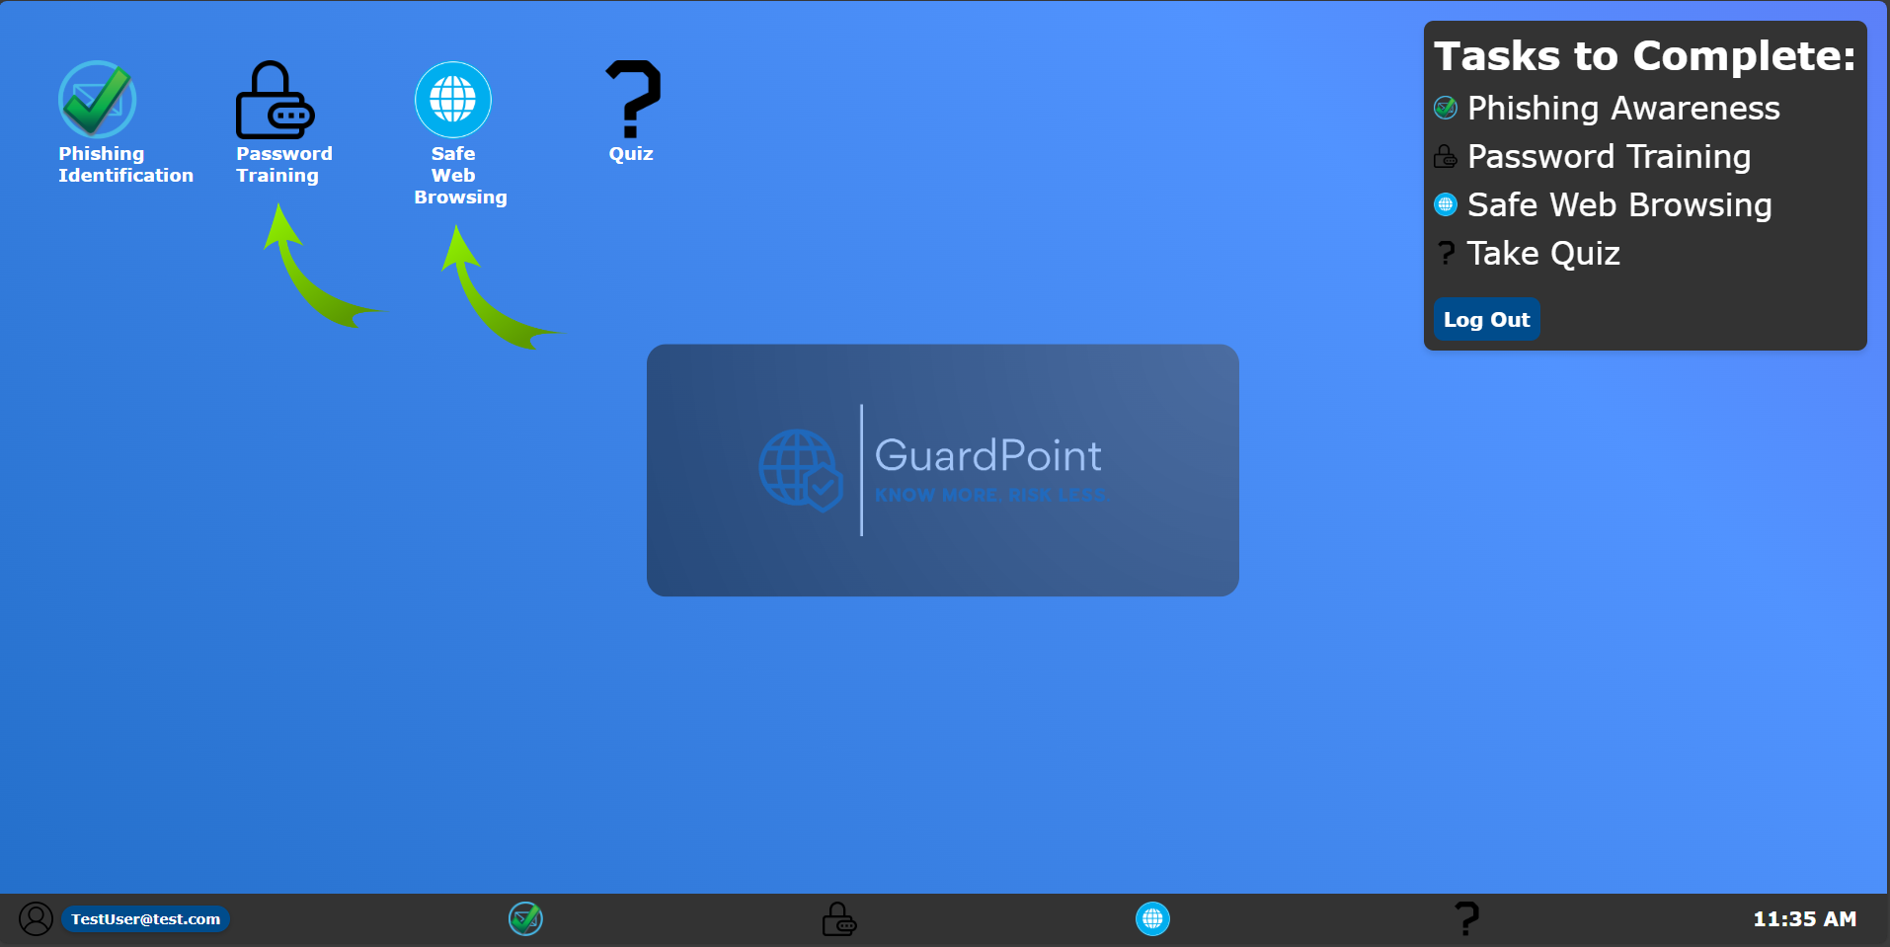

Figure 18 - Desktop

## Profile

The profile contains information of the user (Figure 19), all of which can be altered except the user’s email (Figure 20). The user can delete their account and data at any time. Once a task is complete a reset button will appear in the profile. The reset changes task status in MongoDB and resets the task (including introduction slides).

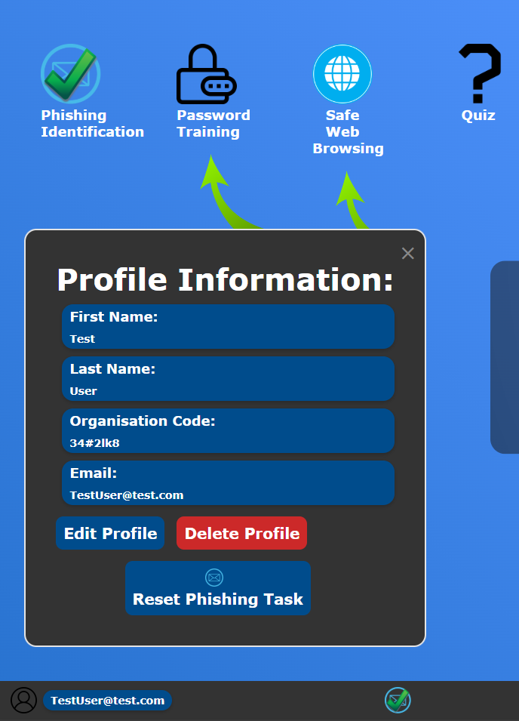

Figure 19 - Profile

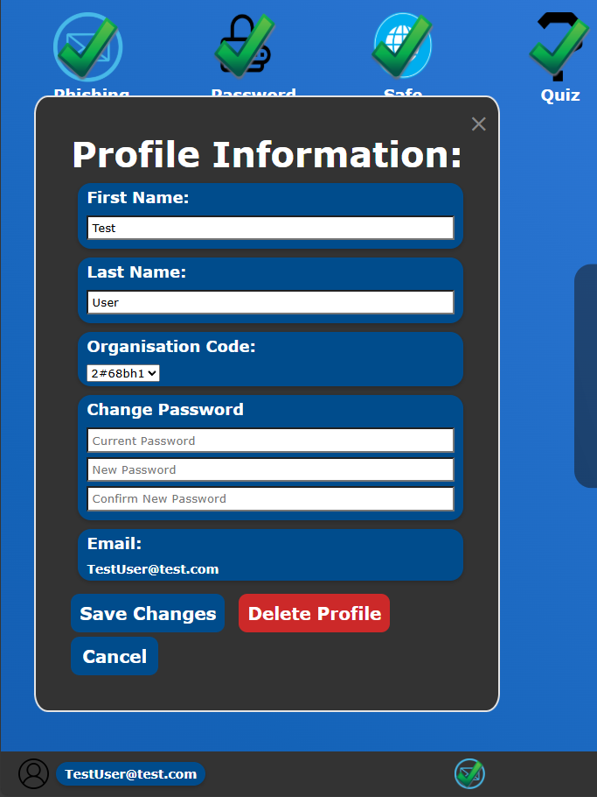

Figure 20 – Edit Profile Information

## Phishing Identification

The phishing task provides introduction slides (unless previously complete) containing relevant information about phishing, aligning with active learning approaches. All buttons are disabled during introduction. After the introduction, a walkthrough on an example email is present with arrows pointing to suspicious parts of the email (Figure 21). The walkthrough email demonstrates hover abilities on links and profile picture to reveal their true sources, encouraging active exploration rather than passive reading - aligning with Constructivist and Experiential Learning theories (Piaget, Vygotsky; Kolb, 1984).

Additionally, the user must highlight words which they believe are suspicious. Highlighted words change colour when the answer is submitted, the words are checked against a predefined list. Colour of highlighted words depends on:

* Green – correct suspicious word.
* Red – incorrect word.
* Orange – Suspicious word which hasn’t been highlighted.

The user must then select which email type they believe the current email is – options include safe email, deceptive, clone or spear phishing. Information on identifying these has been previously taught but a reminder box is available too.

Immediate feedback directly reflects findings by Prümmer (2023) and O'Brien (2025), who emphasise that gamified learning and real-time feedback enhance retention and engagement.

For realism, example emails use the users first name and the current date. The four premade emails provide feedback about why each email corresponds to its email type.

After completing the four premade emails, the user is informed the next emails are generated using OpenAI. Therefore, the emails are unique and demonstrates OpenAI’s capabilities, while reinforcing learned skills through varied examples. This supports the continuous reinforcement approach recommended by Krombholz (2015). Again, OpenAI is fed the users first name in its prompt to improve results.

To complete the task the user must complete the first example email, identify 5 phishing emails correctly and highlight 10 suspicious words correctly - present in the bottom right of the task. The focus on phishing identification addresses the need for better awareness, as phishing remains the most common cyberattack vector and phishing click rates tripled in 2024 (Lucian Constantin via CSO, 2024).

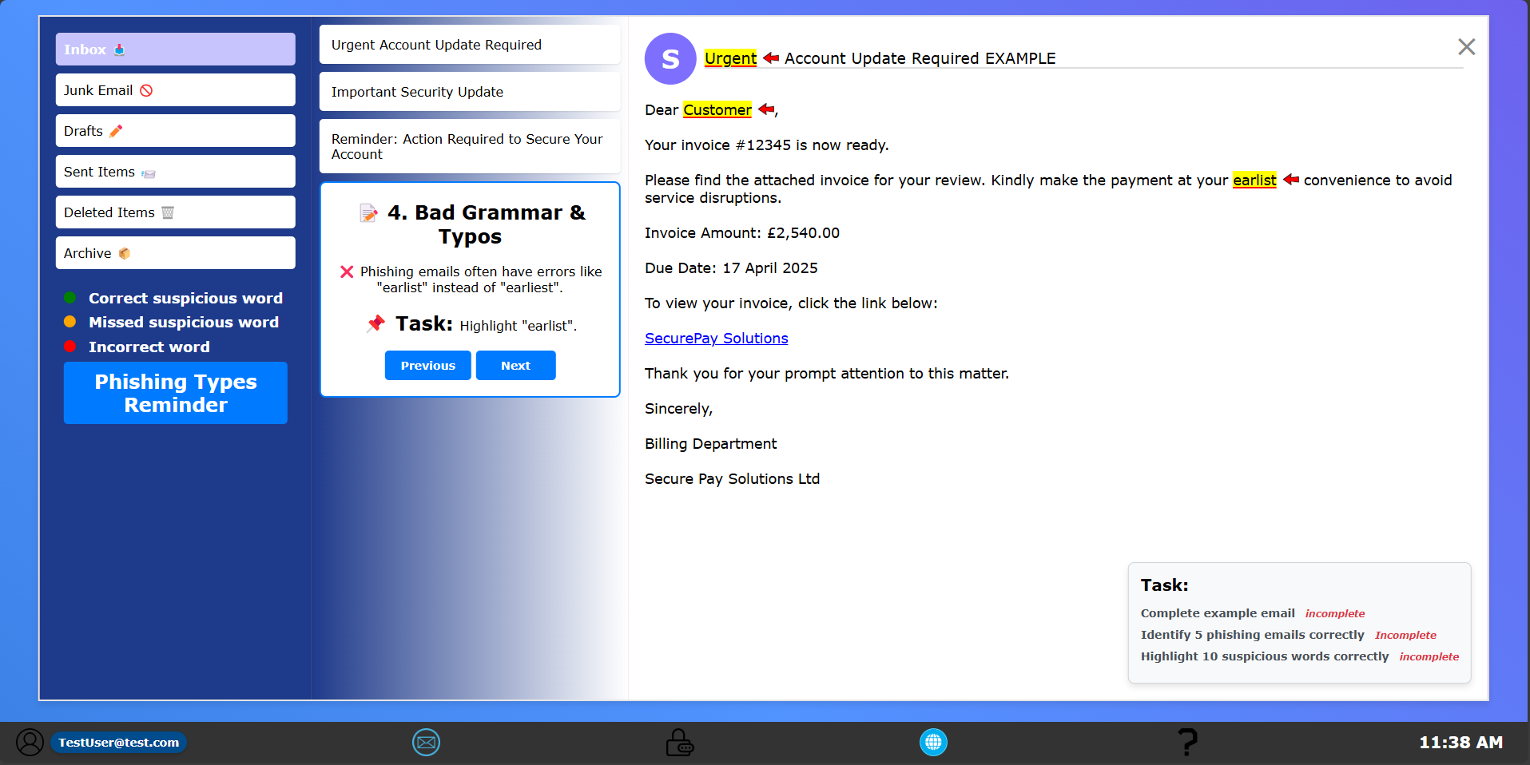

Figure 21 – Phishing Identification Task

## Password Creation

Introduction cards contain information to complete the password task is present when opening the task, unless previously completed. All buttons are disabled during introduction cards.

After the introduction cards the top third of the password task (Figure 22) is unblurred revealed the first stage. This involves checking passwords against the ‘Have I Been Pwned’ (HIBP) database to check for data breaches. The user must test a total of 5 passwords before stage two in unblurred. This hands-on interaction supports Constructivist learning by encouraging users to build understanding through real-world engagement.

Stage two involves the user creating a new password based on the National Cyber Security Centre (NCSC) guidelines. The input box changes colour to indicate strength based on a criterion (use of capital, number, special character etc). This provides immediate feedback that improves engagement and retention (Prümmer, 2023; O'Brien, 2025). The password box must change to green to unlock stage three.

Stage 3 provides a button to test the new password against HIBP, reinforcing the lesson that even strong passwords must be verified. This reflects research by Woods and Siponen (2024) on cognitive challenges users face when adopting secure password habits. The task addresses the common weakness in password practices identified by the NCSC and cybersecurity literature (Coker, 2023).

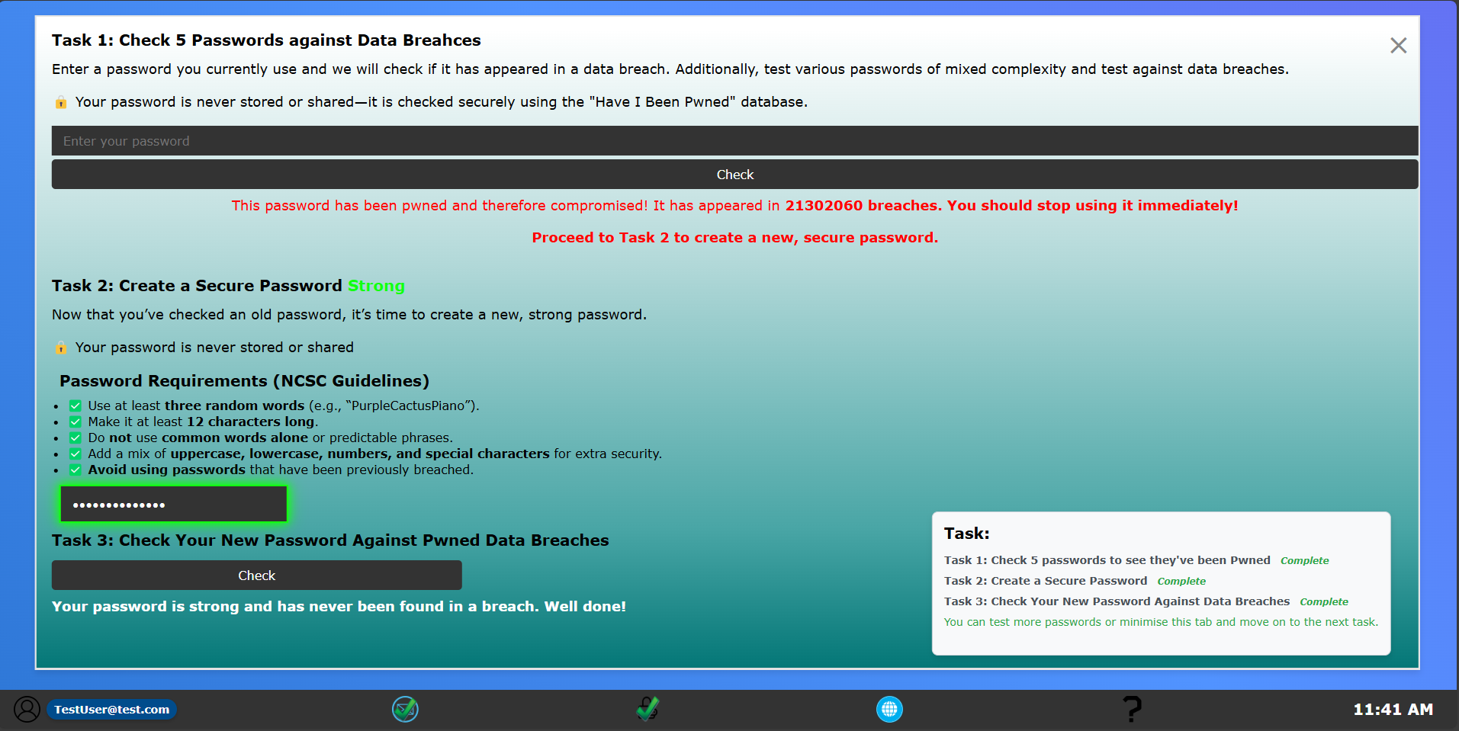

Figure 22 – Password Creation Task

## Safe Web Browsing

Introduction cards containing information to complete the Safe Web Browsing task is present when opening the task, unless previously completed. All buttons are disabled during introduction cards.

The first stage of the Safe Web Browsing task is to use the provided search bar. Results are generated using OpenAI to give a realistic feel of a web browser and to provide results based on the users input (Figure 23). Following the provided instructions and on-screen prompt, the user will receive feedback per provides web search (total of 6 results) about whether the result is safe or not and why. This design follows Constructivist principles (Piaget, Vygotsky) by encouraging users to learn through exploration and immediate feedback, shown to improve retention (Prümmer, 2023; O'Brien, 2025).

Once the user has revealed feedback for all web searches the game becomes available. The user is informed that they can carry out more searches to gain a better understanding or play the game if they’re ready to do so. The game uses the same input from the search bar and generates 12 results which are spread across the screen. Many adjustments to the code have been made to ensure that there is no major overlapping between displaying results. Once results are displayed a 30 second timer begins. In this time the user must identify as many safe links as possible by clicking on them (Figure 24). Points are awarded for correct links and deducted for incorrect links. A score of 4 must be achieved to past the test (1 point per correct answer and -2 per incorrect answer).

This task directly addresses the growing threat of malicious websites and techniques like typosquatting (Zieni, 2021). It provides users with the critical skills needed to identify dangerous links in an engaging environment.

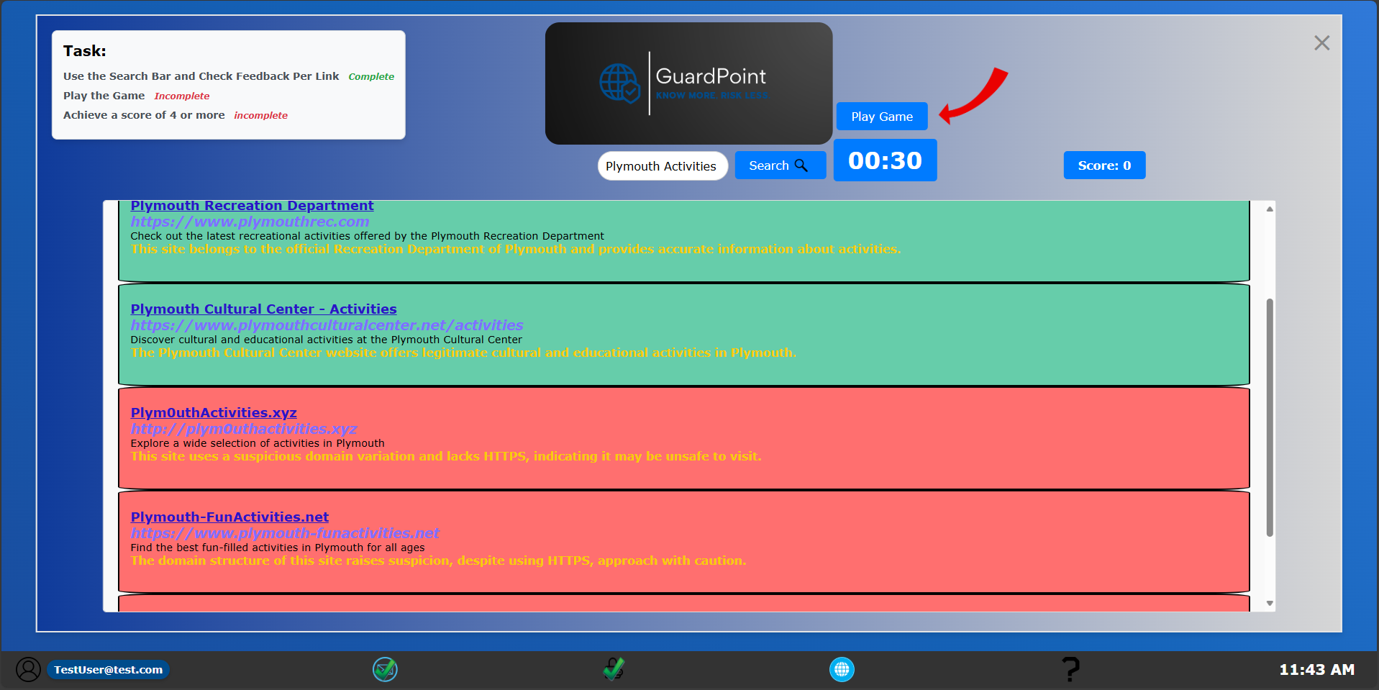

Figure 23 – Web Results

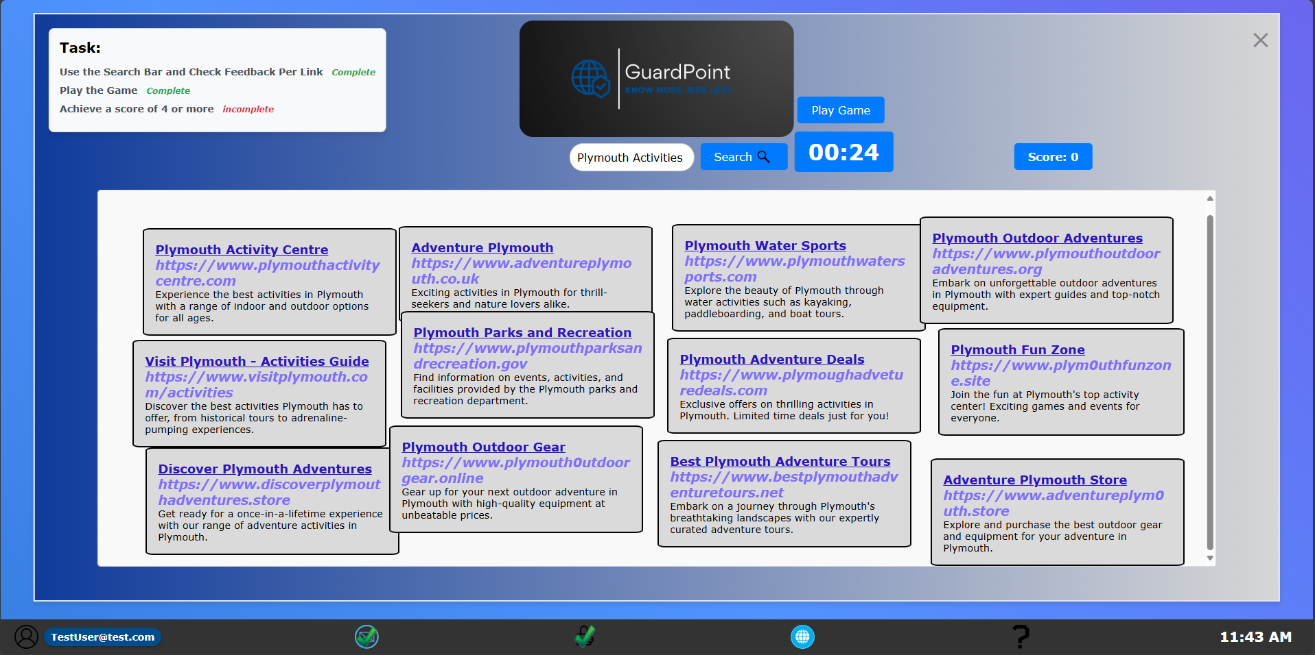

Figure 24 – Web Game

## Quiz

After completion of all three tasks the quiz is available (Figure 25). The quiz contains 15 questions, 5 per task covered. Included is a progress bar and question counter. Questions have been designed based on information taught.

A pass mark is calculated per task (at least 3/5). If the mark is not achieved, the appropriate task(s) will be reset.

Results display scores per task, pass/fail per task, overall mark and average. A pie chart is displayed to visualise strength per category (contains correct questions per task) – Figure 26. Result page adds a re-do button for any failed tasks.

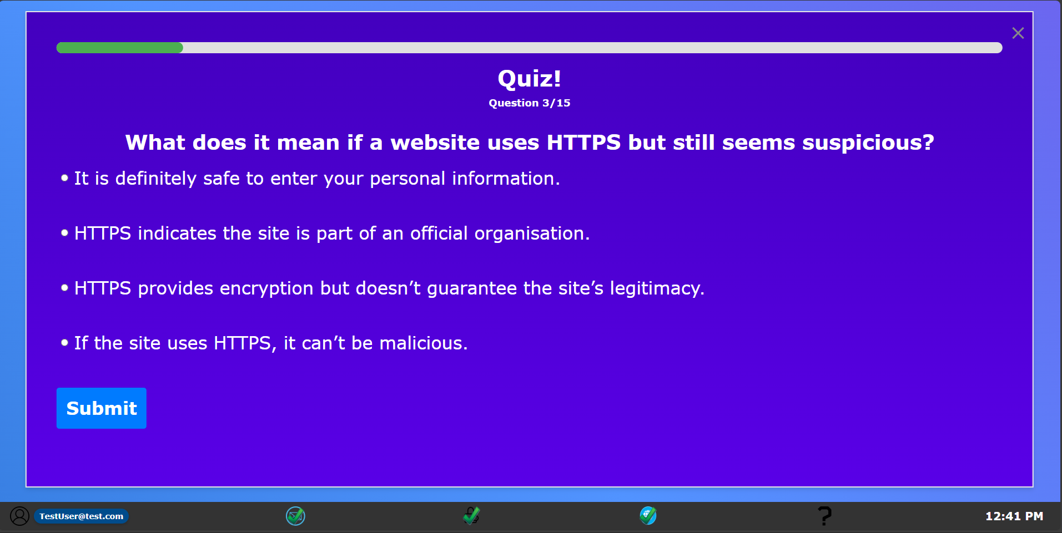

Figure 25 – Quiz Questions

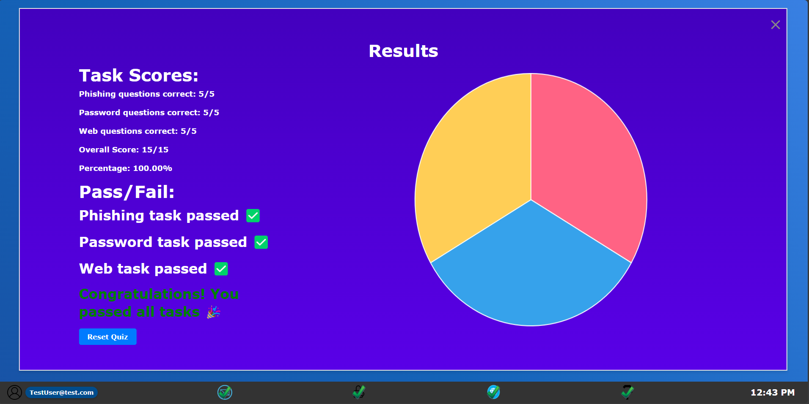

Figure 26 – Quiz Results

## Admin Dashboard

Users are manually given the ‘admin’ role to access the admin dashboard. Designed for organisation leaders/ appropriate roles to check progress of users in their organisation. The admin dashboard displays all users within the admin’s organisation. Information of users is displayed in a table displaying tasks complete, quiz scores and if the user has passed (Figure 27). Admins are excluded from the table. An organisational average is calculated from the users who have completed the quiz.

Admins can reset tasks or quiz at any time per user. Reset buttons only appear if a task/quiz is complete. Additionally, a graph view is available for better visualisation (Figure 28). A bar chart displays scores of the quiz per user, it includes an average score line and a pass mark line. A pie chart shares information of how many users have passed/failed or not yet completed the quiz.

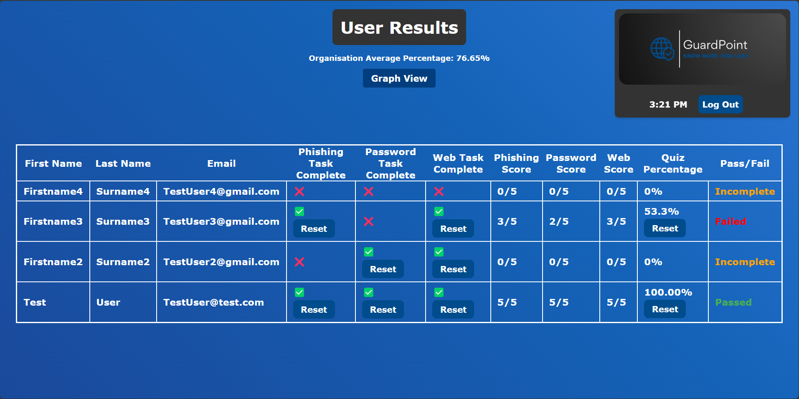

Figure 27 – Admin Dashboard

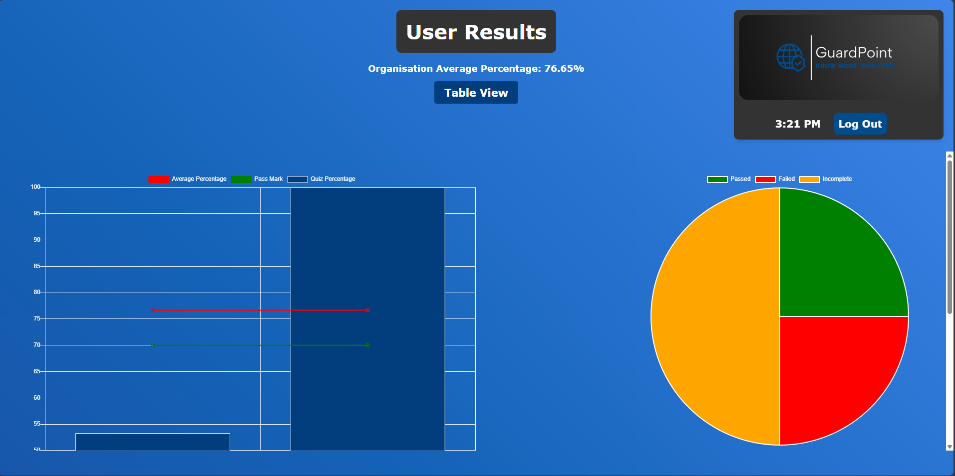

Figure 28 – Admin Graph View

## Table of Features

All MVP, Core and additional features were achieved, exceeding expectations. MVP features ensured essential functionalities such as user authentication, task tracking and admin monitoring. Core features expanded the platform’s interactivity, while additional features introduced integrations such as OpenAI and ‘'Have I Been Pwned' APIs, enhanced visual feedback and user management options (profile edit and delete). Full feature table available in Appendix 11.

# Testing

## Unit Testing

Unit Testing involves isolating individual units of GuardPoint and conducting tests. The end goal is to determine if each unit functions as intended individually. This helps reduce the number of bugs and pinpoints problems.

Vitest was used to conduct testing due to its speed and easy integration with JavaScript. It is ideal for dealing with testing asynchronous routes and database interactions due to the support of ‘mocking’. Mocking ensures that tests are performed in a controlled environment without interacting with the real database, which enhances reliability and prevents unintended data modifications.

The testing focused on routes interacting with the MongoDB database and external APIs such as OpenAI. Prior to the result this helped me identify issues within the code such as Sign-Up functionality allowing invalid criteria. A total of 21-unit tests have been performed (Figure 28), and an example of a few unit tests have been given in Figure 29.

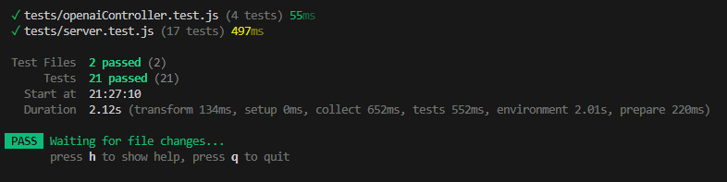

Figure 28 – All Unit Tests

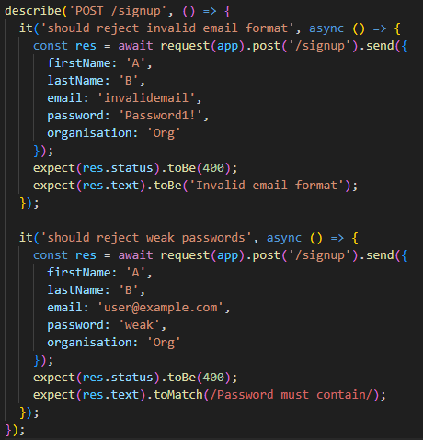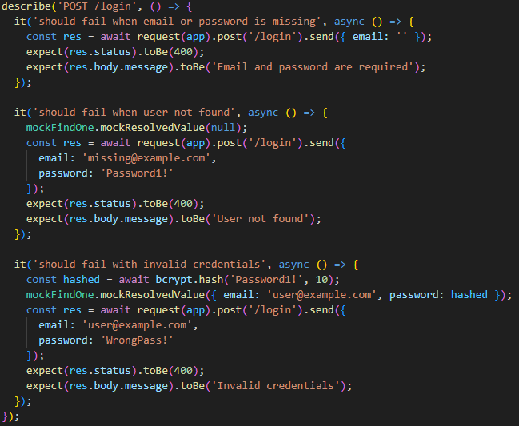

Figure 29 – Example Unit Tests

## Integration Testing

Integration Testing involves verifying the functionality of multiple components within the system. Unlike unit testing, which focuses on individual functions in isolation, integration testing ensures that interconnecting parts work correctly together. Many of the parts tested in GuardPoint rely on multiple functions. Over 60 parts have been tested, and the full table can be found in Appendix 4.

## User Testing

Due to the agile approach and the continuous improvement of GuardPoint, testing was conducted throughout development. Early user testing involved feedback from a small batch of users testing the website hands on. This feedback was verbal and not a predefined set of questions. Feedback was also gathered during supervisor meetings from other students within the same meeting group.

A main concern from early feedback was the lack of a flow between activities and the project not having a direction, ultimately leading to it being hard to complete. To combat the problem implementation of introduction cards, arrows and icons changing to ticks once completed were made.

Furthermore, to confirm the solution had been successful and to gain feedback on the finished project, a set of questions were made (Appendix 7) and user testing was conducted.

User Testing collected valuable results and showed positive feedback in most aspects of the project (Figures 30 and 31). The testing was conducted on real world users with no target demographic (Figure 32). The purpose of this is because GuardPoint is designed for all ages and all technical abilities. Included in the questions is one to gauge the technical ability of the user. The purpose of this is to test all technical abilities. The full User answers can be found appendix 8.

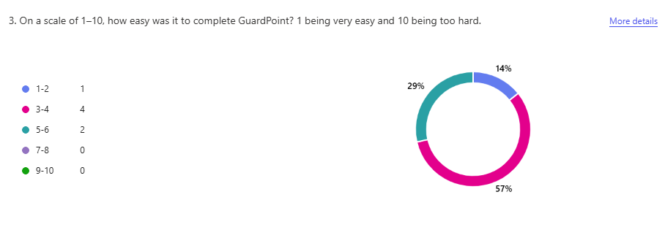

Figure 30 – GuardPoint Difficulty

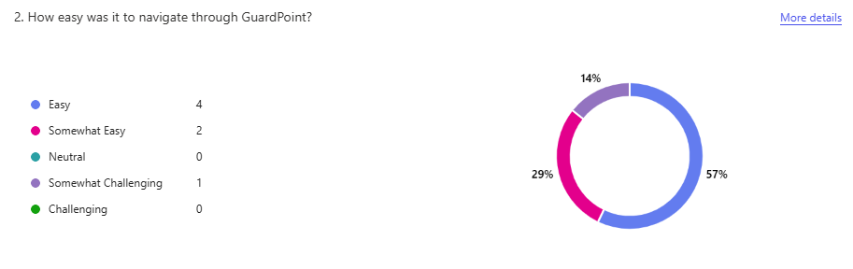

Figure 31 – GuardPoint Navigation

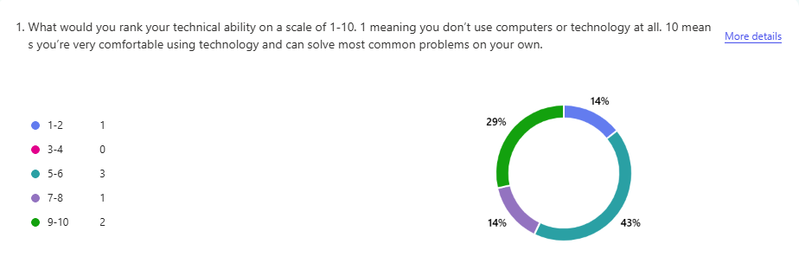

Figure 32 – GuardPoint Test Users Technical Ability

# End-Project Report

## Summary

GuardPoint was a great successful with all milestones being achieved to a high standard and completed on time. GuardPoint is a fully functional web-based interactive Cyber Security training platform. The tool is designed to educate users on password safety, phishing recognition and safe web browsing practices. All of which has been successfully achieved.

The project has exceeded my expectations with the additional use of OpenAI for unique and realistic web searches and email generation. Alongside, the platform features full database integration, enabling the admin dashboard to effectively monitor user progress and reset tasks as needed.

The development of GuardPoint has taught me more than what I could have ever expected. Many challenges have been navigated successfully such as technical difficulties, poor file structure, ineffective ai models and how to take on board user feedback. Ultimately, I have improved my knowledge of full-stack development, my problem-solving skills and adopted project management practices that will stay with me in my future work.

## Project Changes

Many necessary changes were made during the development of GuardPoint to get to the finish project. A major change was making the choice of narrowing down the task list from six brief exercises to three in depth exercises. In reflection this was the right choice and allowed more time to be spent on the most relevant and important tasks.

The other change was to integrate external APIs into the project. Such as OpenAI. The purpose of this was to allow for demonstration of what OpenAI is capable of and to generate unique, tailored results for the user to give a more realistic feel. The other API being ‘Have I been pwned’ – this proved essential and added a new layer of depth to the password task by allowing users to check their passwords against real data breaches.

Lastly, a notable change during Sprint 6 was the choice to redesign the file structure of the project. This led to better coding practices and although time intensive, it allowed for better development and future enhancements.

## Objective Review

### Provide an educational interactive Cyber Security Training tool that any employee can complete regardless of technical ability.

Achieved. All tasks include an introduction and walkthrough, when necessary, supportive UI, and simplified language suitable for all users.

### Provide a quiz to test new learnt knowledge.

Achieved. All tasks lead to a knowledge test via a 15-question quiz, dynamically generated with feedback. Questions are based on the information taught – 5 per subject.

### Provide a functional sign up and log in system with progress tracking to keep progress between sessions.

Achieved. User data is saved in MongoDB and updates dynamically across sessions.

### Provide an admin dashboard for tracking and resetting of employee progress.

Achieved. Admins can monitor users within their organisation, view quiz performance, and reset tasks/quiz.

### Provide interactive tasks, not just information on a screen.

Achieved. All exercises are simulated with feedback loops, visuals, and simulate real-world activities.

### Allow user information to be edited and deleted.

Achieved. Users can access profile settings to edit or delete their data.

# Post-Mortem

## Objectives Evaluation

The aim was to provide an educational interactive Cyber Security Training tool that any employee can complete regardless of technical ability. All objectives were met whilst keeping a high standard and implementing beyond the initial proposal.

## Developer Evaluation

Over the duration of GuardPoint the guideline of 400 hours invested has been met, with effective time management. Version control (via commit history) demonstrated how work has stayed consistent.

Appropriate plans have been used to achieve the end product and MVP all within set time. Skills have been strengthened in full-stack web development such as management of MongoDB databases, password hashing, role-based access and designing asynchronous front-end interactions.

Significant improvements were made through a continuous cycle of reflection and user feedback. Changes such as file reconstruction, removing unnecessary personal data (Date of Birth) and implementing organisational codes rather than names all reflected an iterative approach.

## Project Management Evaluation

Gannt Charts and Trello boards helped project management remain strong throughout the project. The initial Gannt Chart was optimistic, around how many tasks were going to be implemented, yet the project was altered appropriately. The ability to respond to scope changes demonstrates the skills in managing evolving requirements.

The consistency of version control and supervisor meetings (to plan sprints) showed strength in affective project management and consistent work. These practices demonstrate strong time management and the use of altering the Gannt Chart further supports these claims.

## Technologies Evaluation

The chosen technology stack - JavaScript, HTML, CSS, Node.js/Express, and MongoDB was the right choice and performed effectively. Given previous background in JavaScript the learning curve was reduced. The use of asynchronous JavaScript (allowing code to run in the background) and modular file separation supported efficient handling of user tasks and front-end responsiveness.

Third-party API integrations such as ‘Have I Been Pwned’ and OpenAI both proved successful and helped incorporate a realistic feel to boost engagement. An attempt was made to incorporate a different AI model via Hugging Face but was unsuccessful (Phase 6). However, due to OpenAI’s limitations (cost and token limit), this is an aspect which would need to be changed upon further work.

## What Went Well

**Full Completion**:

All core elements plus additional features implemented successfully, providing an interactive and gamified experience - backed with positive user feedback. Demonstration of an effective software development lifecycle.

**OpenAI Integration**:

* Sets GuardPoint apart from other training and provides tailored results.
* Prompts were iteratively refined (10+ changes per prompt) for accuracy.
* Data from OpenAI was correctly formatted, stored in arrays, and dynamically displayed.
* Integration was efficient due to pre-existing email logic.

**Admin Dashboard:**

* Initial goal of viewing user progress by organisation was met.
* Extra functionality – individual task and quiz resets per user. Required careful handling of MongoDB queries.
* Unique reset buttons created per user per task/quiz by using that user’s email for identification on each button.

A snippet of the code used in creating unique reset buttons code has been provided (Figure 33) - this was performed per user in the given organisation.

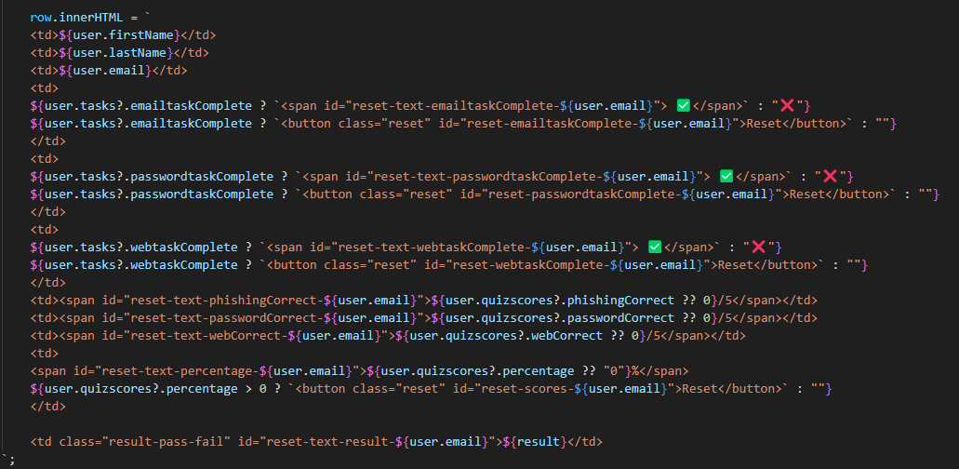

Figure 33 – User Reset Buttons Functionality

## What Could Have Gone Better

**Modular Code Structure**:

* Early use of modular code practices would have avoided time spent reconstructing.
* Shared logic could have reduced code repetition – a single shared variable to check if a task is open could have been used instead of complex IF statements – Figure 34.

**Feature Creep**:

* Phishing identification task complexity exceeded initial scope, consuming too much time.
* All tasks should have been completed, before adding enhancements.

**Late Testing**:

* Unit tests were only written post-development.
* Early tests in line with a route creation would have helped in debugging problems.
* Early user testing would have helped planning tasks before they were fully built.
* Earlier user testing could have provided better task flow and reduced revision time.

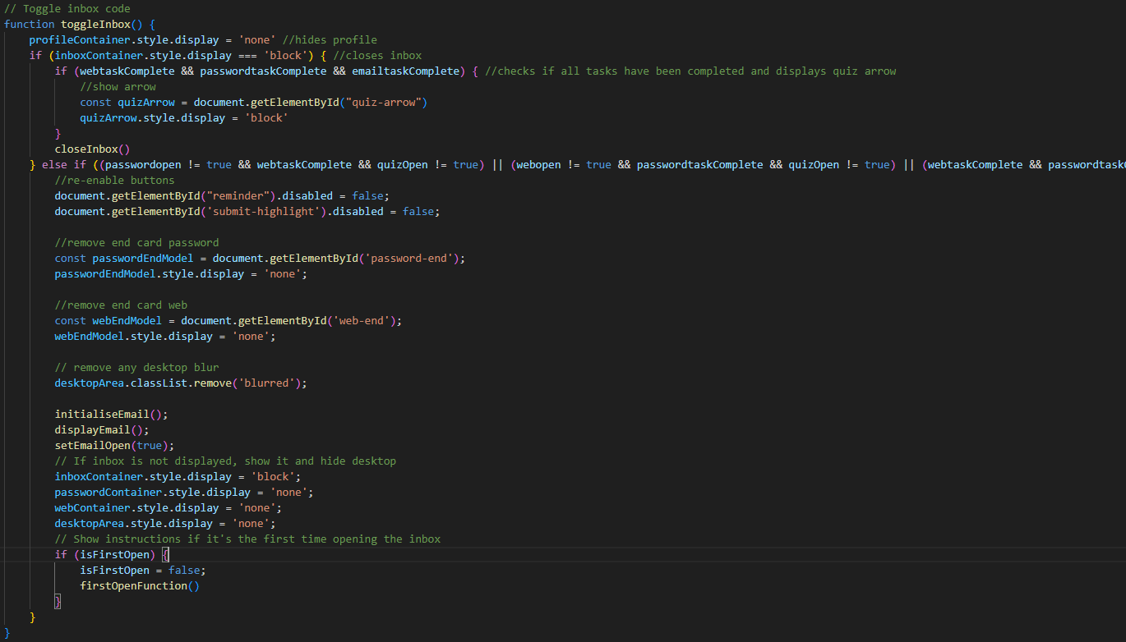

As seen, this is much too long.

Figure 34 – Complex Logic

## Future Work

The software development lifecycle is continuous. Future elements and tasks can always be implemented. OpenAI web and email generation will become more sophisticated, enabling future development to be more effective. Alternatively, integration a new model from a free platform, improving the prompt and aligning the version used to the latest release could better results.

Implementation of new tasks (which were first aimed to be implemented) could also be worked on. Including recognising insider threats and mobile device security. Although these could not be implemented, it was the right decision to develop more complex core tasks rather multiple tasks lacking depth.

Adaptive learning is another method which could be used to improve the training. This involves changing the training difficult based on the user’s technical ability. This was not the focus in the current project due to the training being designed for all levels to complete, however this would help improve training quality for users of higher technical ability.

Outside of the training itself, the functionality for a user to change their email is a future requirement. Due to the email being used as a primary key in MongoDB it would have been too time consuming to implement this functionality. Within the future this would involve an email confirmation to confirm the change of an email address.

# Conclusions

GuardPoint has been successful in achieving its primary objective of creating an engaging, accessible and interactive cybersecurity training platform designed for users of all technical abilities. This has been done through the combination of active learning methods, immediate feedback and real-world simulations.

GuardPoint effectively addresses the major vulnerabilities associated with phishing, weak password practices, and unsafe web browsing. Integration of OpenAI and Have I Been Pwned APIs further enhances realism and user engagement, while the admin dashboard provides essential tools for organisations to monitor and support employee progress.

Careful planning across method of approach, design, architecture, project management, requirements gathering, LSEP considerations and available academic literature enabled GuardPoint to result in a stable and scalable project. Strong software engineering principles, testing, user feedback and risk assessments were all applied during development. Challenges were successfully navigated such as refining project scope and reconstruction of the file architecture. Ultimately this improved the project quality and maintainability.

Cybersecurity training can move beyond passive video-based methods - GuardPoint has proved this point and can deliver a more impactful learning experience. The project exceeded initial expectations and met all outlined objectives.

Future opportunities, such as additional modules and adaptive learning paths, show how GuardPoint is well positioned to further strengthen cyber awareness in organisations. Furthermore, tasks can continue to evolve in response to emerging threats.

# Reference List and Bibliography

Beyer, H., Holtzblatt, K. and Baker, L.E. (2004). An Agile Customer-Centered Method: Rapid Contextual Design. pp.50–59. doi:<https://doi.org/10.1007/978-3-540-27777-4_6>.

BS EN ISO/IEC 27000:2020 Oclc.org. (2020). British Standards Online. [online] Available at: <https://bsol-bsigroup> com.plymouth.idm.oclc.org/Bibliographic/BibliographicInfoData/000000000030394210.

BS EN ISO/IEC 27001:2024 Oclc.org. (2024). British Standards Online. [online] Available at: <https://bsol-bsigroup> com.plymouth.idm.oclc.org/Bibliographic/BibliographicInfoData/000000000030486838.

BS EN ISO/IEC 27002:2022 Oclc.org. (2022). British Standards Online. [online] Available at: <https://bsol-bsigroup> com.plymouth.idm.oclc.org/Bibliographic/BibliographicInfoData/000000000030452034.

Cisco. (2024). Security Certifications. [online] Available at: <https://www.cisco.com/site/us/en/learn/training-certifications/certifications/security/index.html#tabs-35d568e0ff-item-4bd7dc8124-tab> [Accessed 26 Apr. 2025].

Coker, J. (2021). NCSC: Large Number of Brits Are Using Easily Guessable Passwords. [online] Infosecurity Magazine. Available at: <https://www.infosecurity-magazine.com/news/ncsc-brits-using-easily-guessable/> [Accessed 22 Apr. 2025].

Google Books. (2025). Constructivism and the Technology of Instruction. [online] Available at: <https://books.google.co.uk/books?hl=en&lr=&id=yS310A35FC0C&oi=fnd&pg=PA1&dq=Duffy+%26+Jonassen> [Accessed 26 Apr. 2025].

GOV.UK (2024). Cyber security breaches survey 2024. [online] GOV.UK. Available at: <https://www.gov.uk/government/statistics/cyber-security-breaches-survey-2024/cyber-security-breaches-survey-2024>.

Haney, J. and Lutters, W. (2020). Security Awareness Training for the Workforce: Moving Beyond ‘Check-the-Box’ Compliance. Computer, [online] 53(10), pp.91–95. doi:<https://doi.org/10.1109/mc.2020.3001959>.

ieeexplore.ieee.org. (n.d.). Phishing or Not Phishing? A Survey on the Detection of Phishing Websites. [online] Available at: <https://ieeexplore.ieee.org/abstract/document/10049452>.

Junior, C.R., Becker, I. and Johnson, S. (2023). Unaware, Unfunded and Uneducated: A Systematic Review of SME Cybersecurity. [online] arXiv.org. Available at: [[2309.17186] Unaware, Unfunded and Uneducated: A Systematic Review of SME Cybersecurity](https://arxiv.org/abs/2309.17186) .

KnowBe4 (2018). Security Awareness Training | KnowBe4. [online] Knowbe4.com. Available at: <https://www.knowbe4.com/>.

Kolb, D. (1984). Experiential learning: Experience as the source of learning and development. [online] Research Gate. Available at: <https://www.researchgate.net/publication/235701029_Experiential_Learning_Experience_As_The_Source_Of_Learning_And_Development>.

Krombholz, K., Hobel, H., Huber, M. and Weippl, E. (2015). Advanced Social Engineering Attacks. Journal of Information Security and Applications, [online] 22(1), pp.113–122. doi:<https://doi.org/10.1016/j.jisa.2014.09.005>.

lconstantin (2025). Phishing click rates tripled in 2024 despite user training. [online] CSO Online. Available at: <https://www.csoonline.com/article/3801010/phishing-click-rates-tripled-in-2024-despite-user-training.html>.

National Cyber Security Centre (2024). Cyber Aware. [online] [www.ncsc.gov.uk](http://www.ncsc.gov.uk). Available at: <https://www.ncsc.gov.uk/cyberaware/home>.

Nelson, R.R. and Cheney, P.H. (1987). Training End Users: An Exploratory Study. MIS Quarterly, 11(4), p.547. doi:<https://doi.org/10.2307/248985>.

O’Brien, H. (2025). Influences on User Engagement. Synthesis lectures on information concepts, retrieval, and services, pp.53–68. doi:<https://doi.org/10.1007/978-3-031-80916-3_4>.

Pbs.org. (2019). Cybersecurity | NOVA Labs | PBS. [online] Available at: <https://www.pbs.org/wgbh/nova/labs/lab/cyber/>.

Prümmer, J., van Steen, T. and van den Berg, B. (2023). A systematic review of current cybersecurity training methods. Computers & Security, [online] 136(103585). doi:<https://doi.org/10.1016/j.cose.2023.103585>.

Ross, G. and Gilbey, A. (2023). Extended reality (xR) flight simulators as an adjunct to traditional flight training methods: a scoping review. CEAS Aeronautical Journal, 14(4), pp.799–815. doi:<https://doi.org/10.1007/s13272-023-00688-5>.

Sans.org. (2021). Available at: <https://www.sans.org/security-awareness-training/>.

TeAchnology (2020). Piaget’s Theory on Constructivism. [online] Teach-nology.com. Available at: <https://www.teach-nology.com/currenttrends/constructivism/piaget/>.

Teach-nology.com. (2020). Vygotsky’s Theory on Constructivism. [online] Available at: <https://www.teach-nology.com/currenttrends/constructivism/vygotsky/>.

Terranovasecurity.com. (2023). Why Modern Design Matters in Cyber Security Training. [online] Available at: <https://www.terranovasecurity.com/blog/modern-cyber-security-training> [Accessed 22 Apr. 2025].

Trello (2024). Trello. [online] trello. Available at: <https://trello.com/>.

Withgoogle.com. (2020). Take Jigsaw’s Phishing Quiz. [online] Available at: <https://phishingquiz.withgoogle.com/>.

Woods, N. and Siponen, M.T. (2024). How Memory Anxiety Can Influence Password Security Behavior. Computers & Security, 137, pp.103589–103589. doi:<https://doi.org/10.1016/j.cose.2023.103589>.

[www.ibm.com](http://www.ibm.com). (n.d.). IBM Training. [online] Available at: <https://www.ibm.com/training/security>.

[www.infosecinstitute.com](http://www.infosecinstitute.com). (n.d.). Explore Infosec IQ Security Awareness Learning Path | Infosec. [online] Available at: <https://www.infosecinstitute.com/skills/learning-paths/infosec-iq-security-awareness/>.

# Appendices

## Appendix 1: User Guide

**Future Deployment**

GuardPoint is not currently live, but in future development GuardPoint is set to be hosted on a live website. Organisations can sign up to GuardPoint and will be provided a unique organisational code which they can provide to their organisation. Users within the organisation can use their organisation code within sign up to access the training.

**Setup and Usage Instructions**

System Requirements:

* A PC or Mac with internet access
* [Node.js](https://nodejs.org/) installed (recommended version 18.x or higher)
* [Git](https://git-scm.com/) installed
* A code editor/IDE (such as [Visual Studio Code](https://code.visualstudio.com/))
* Access to the private GitHub repository

Access is limited without the given .env file. Without the necessary API keys the database, ‘Have I been pwned’, OpenAI (Phishing generation and web simulation) will NOT work.

Setup Steps:

1. Cone Repository
2. Install dependencies – use ‘npm install’ within selected IDE.
3. Start the server using ‘npm start’.
4. Open web browser and navigate to local host: http://localhost:3000

## Appendix 2: API Route Table

|  |  |  |  |
| --- | --- | --- | --- |
| **Route** | **Method** | **Description** | **Request Body Parameters** |
| /signup | POST | Register new user | firstName, lastName, email, password, organisation |
| /login | POST | Logs in user and generates a JWT token | email, password |
| /update-tasks | POST | Updates user task completion status. | email, taskName, status |
| /update-scores | POST | Updates user quiz scores. | email, phishingCorrect, passwordCorrect, webCorrect, percentage |
| /update-profile | POST | Updates user profile information. | email, firstName, lastName, organisation |
| /delete-user | DELETE | Deletes a user by email. | email |
| /change-password | POST | Changes the user's password. | email, currentPassword, newPassword |
| /generate-game | POST | Generates a game with 12 search results (6 safe, 6 malicious). | userMessage |
| /generate-answer | POST | Generates 6 search results (3 safe, 3 unsafe) based on the user query. | userMessage |
| /generate-phishing | POST | Generates a phishing email based on the user's first name. | firstName |

## Appendix 3: User Stories

* As a user I want to sign up and login into my account.
* As a user I want my account to save my progress.
* As a user I want to change my information.
* As a user I want to learn cyber security concepts.
* As a user I want a realistic experience.
* As a user I want to test my knowledge.
* As a user I want an interactive experience.
* As a user I want to see what I score per task.

## Appendix 4: Integration Test Table

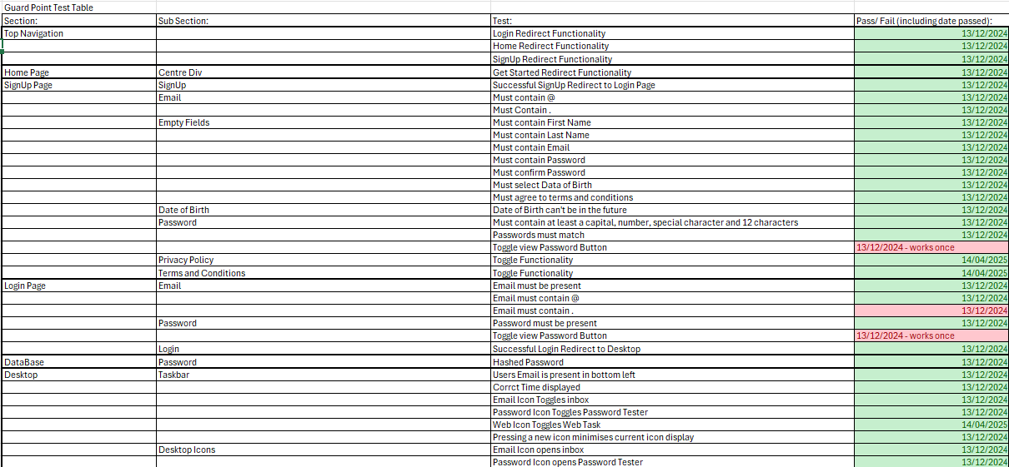

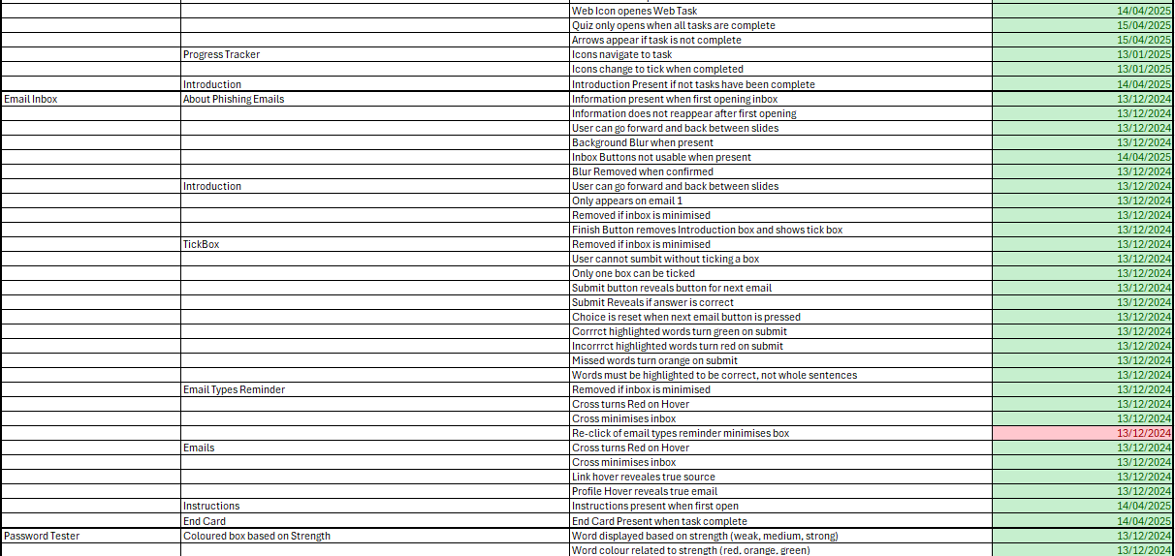

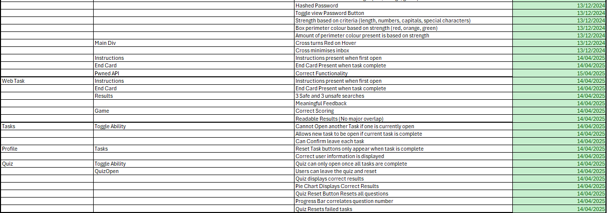

## Appendix 5: Privacy Policy

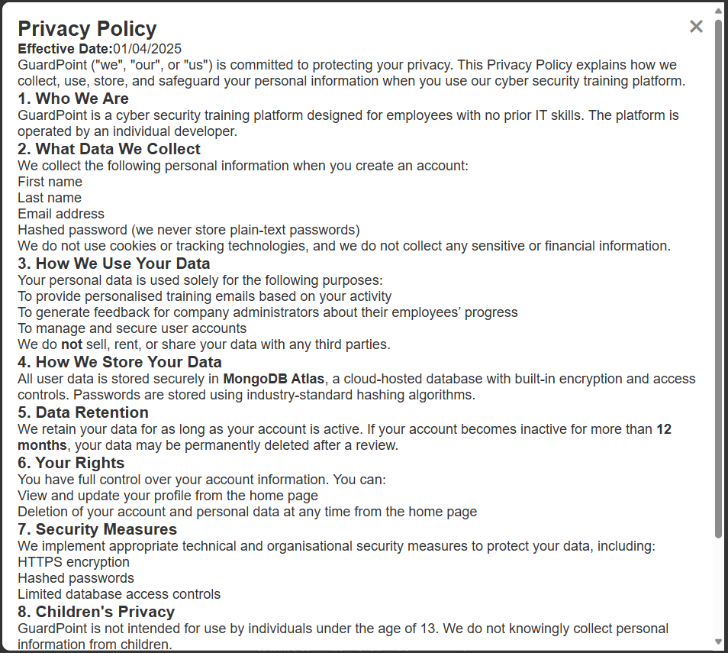

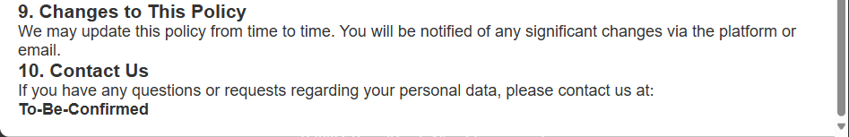

## Appendix 6: Terms and Conditions

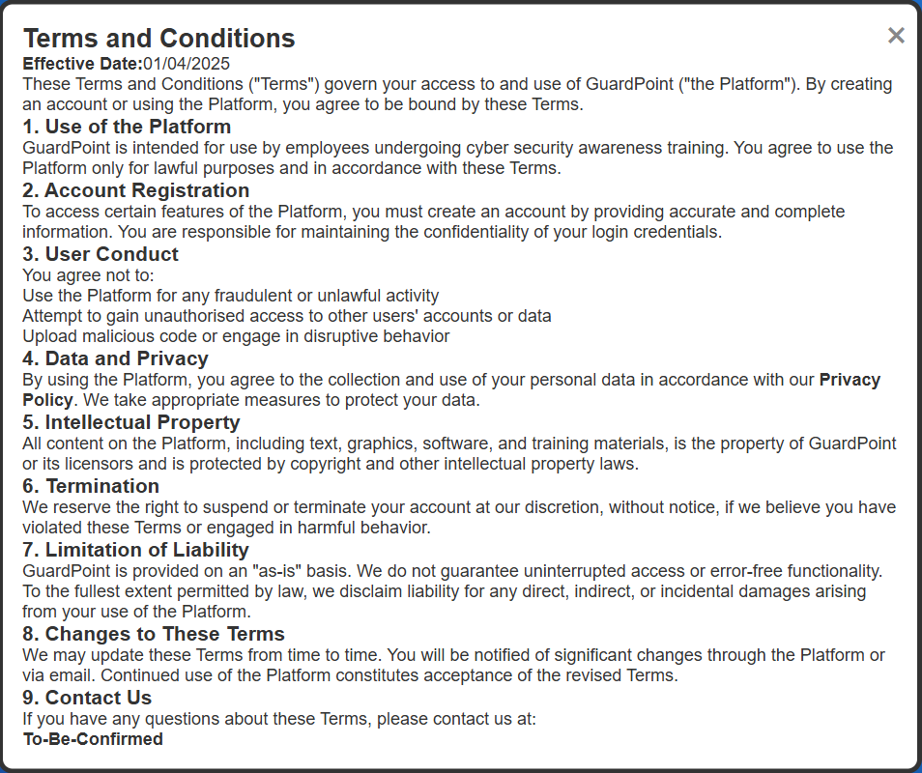

## Appendix 7: User Feedback Questions

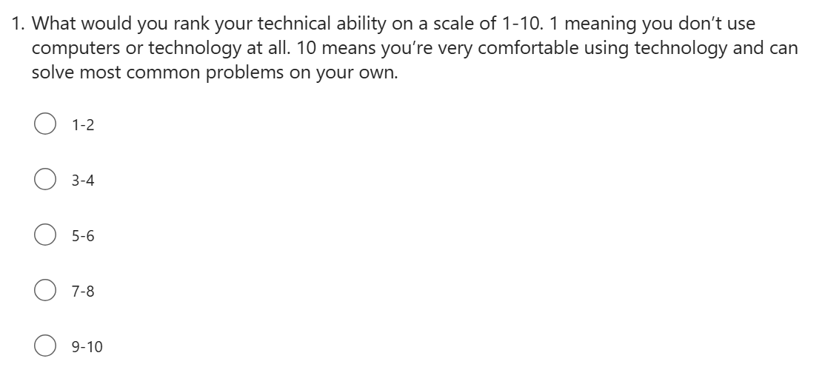

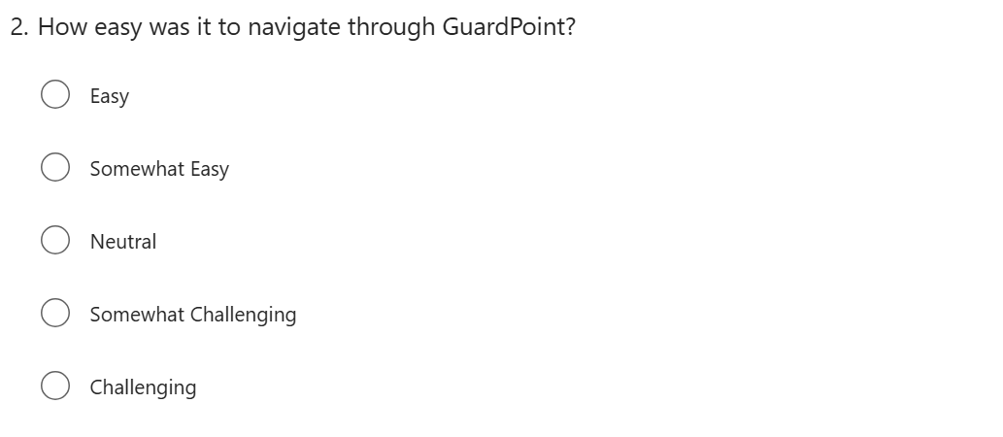

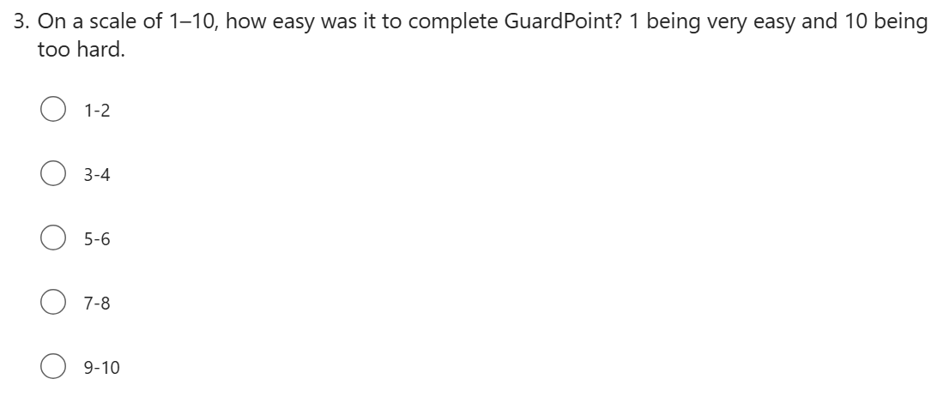

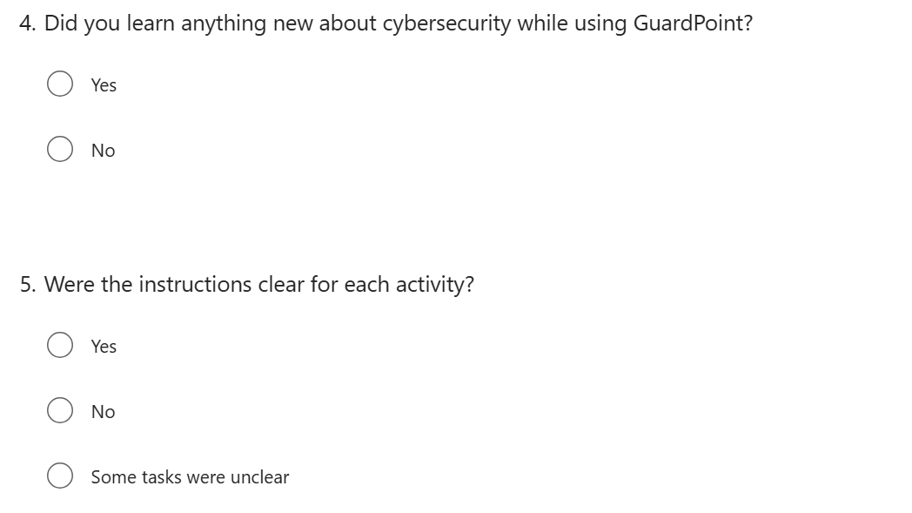

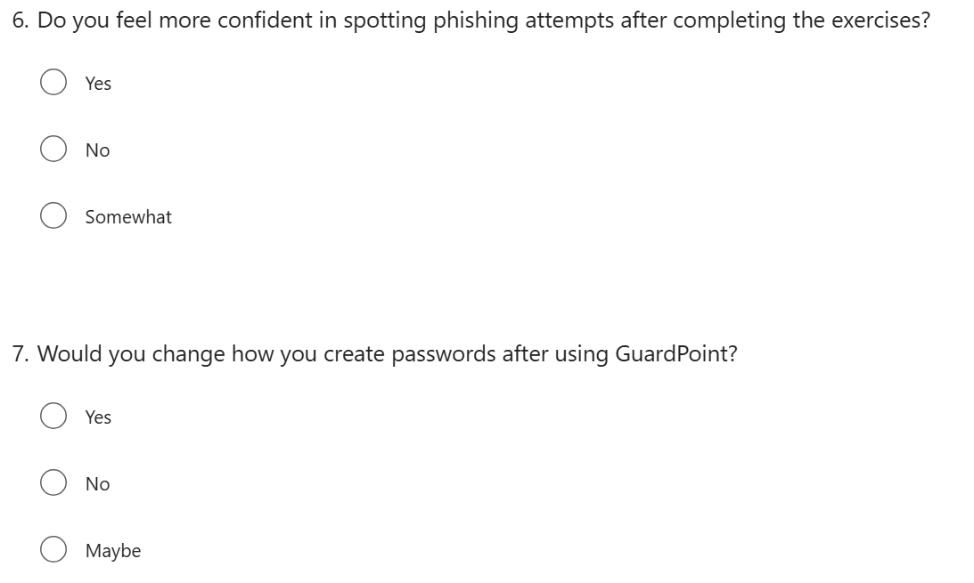

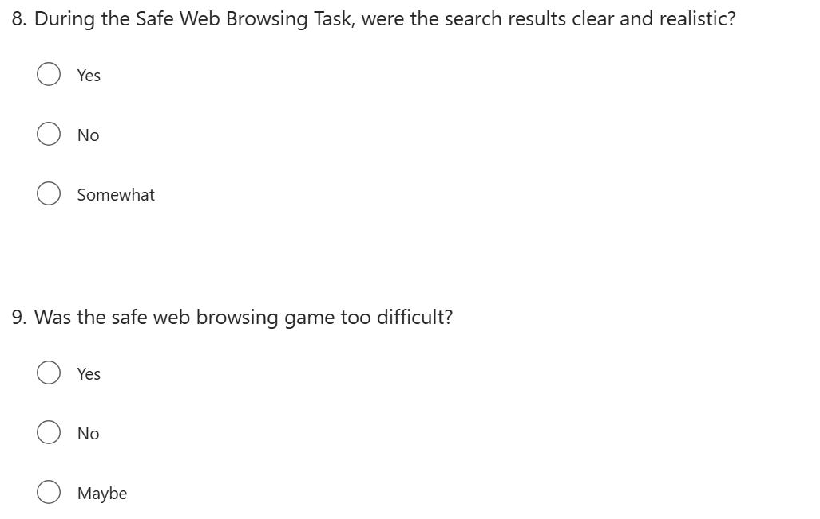

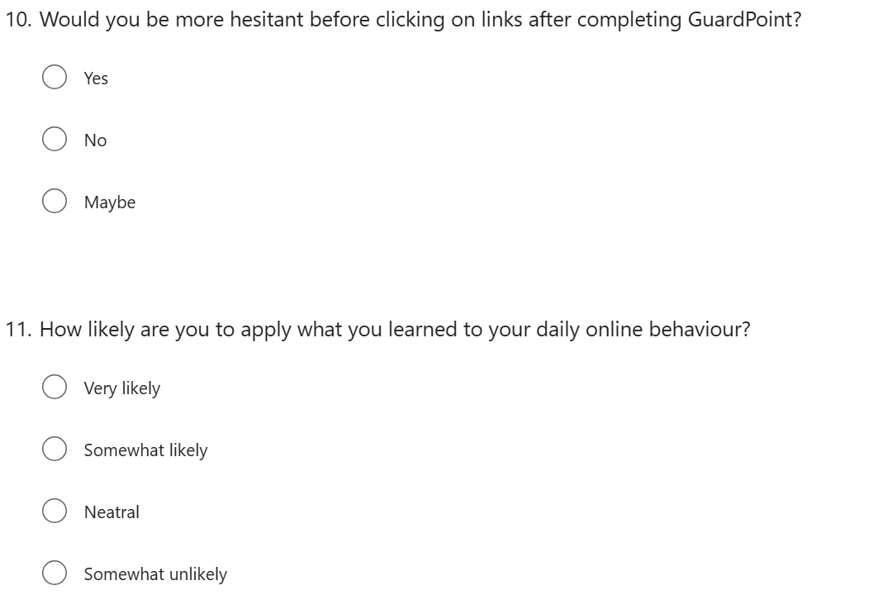

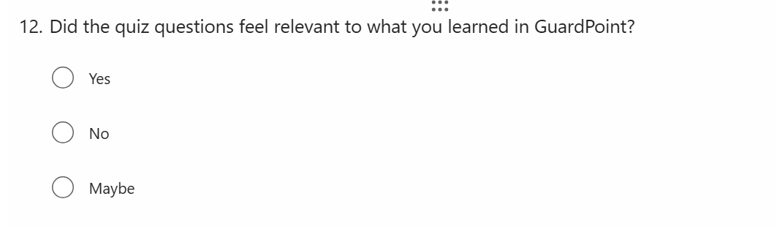

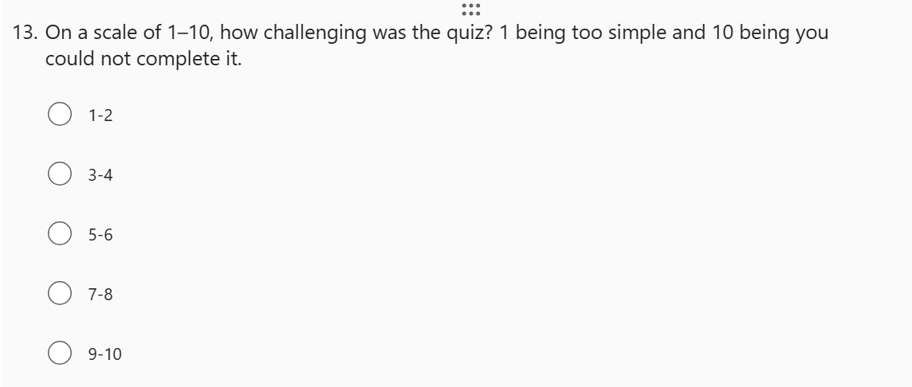

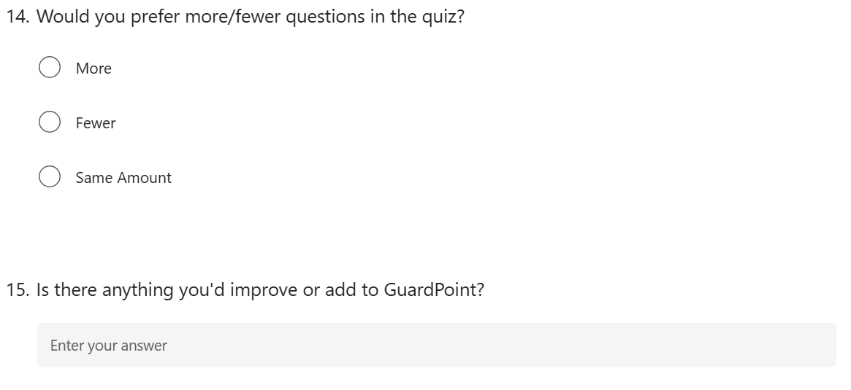

## Appendix 8: User Feedback Answers







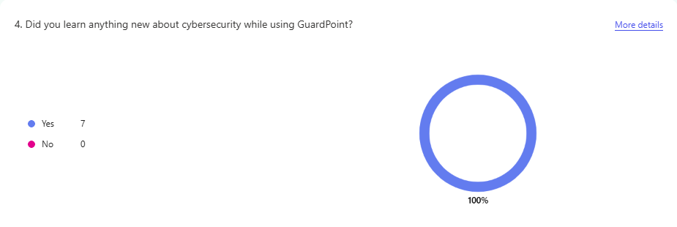 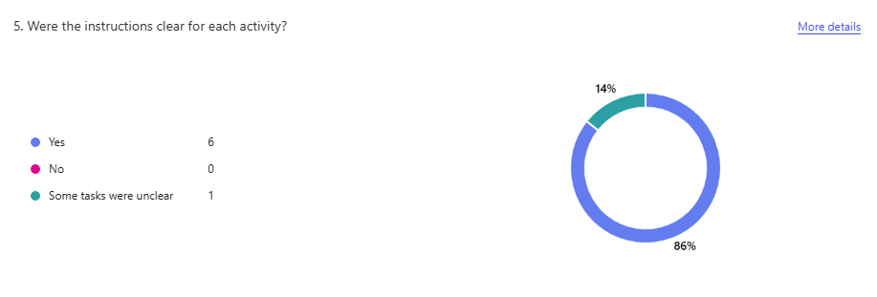

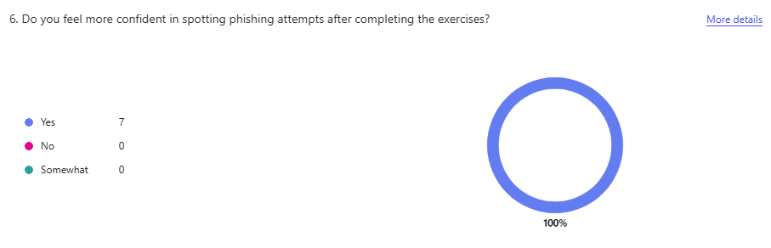

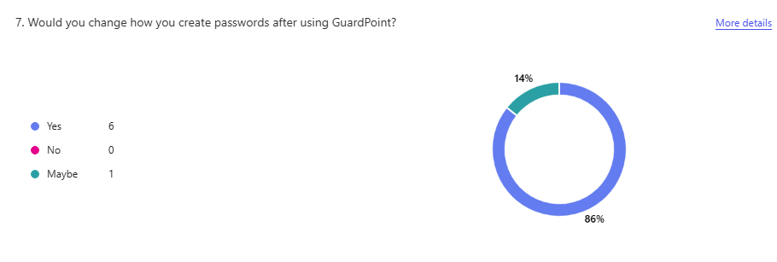

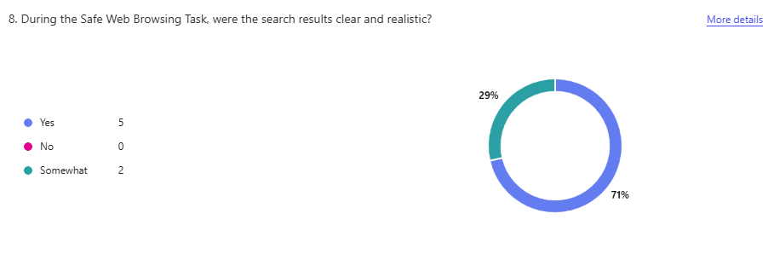

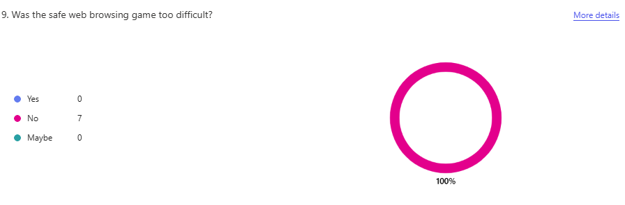

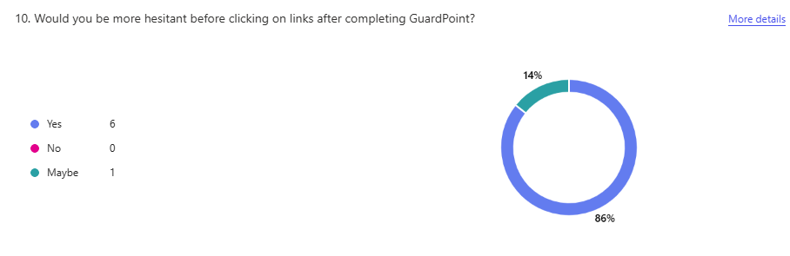

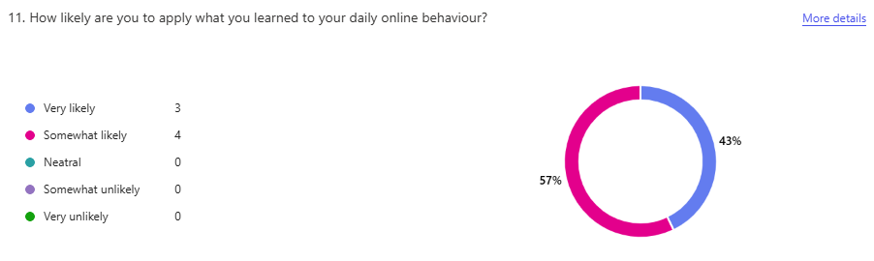

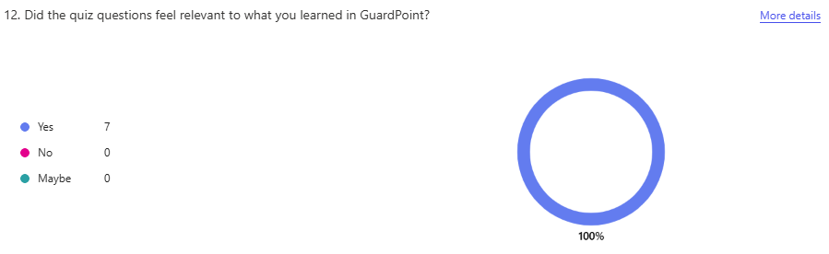

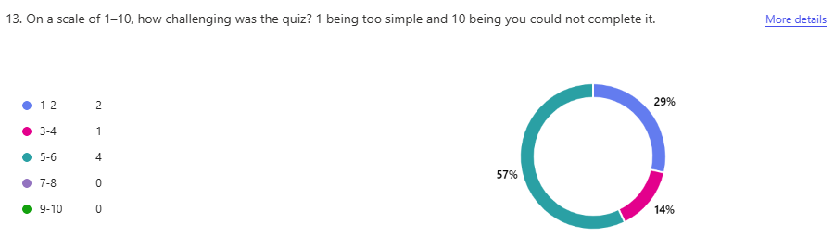

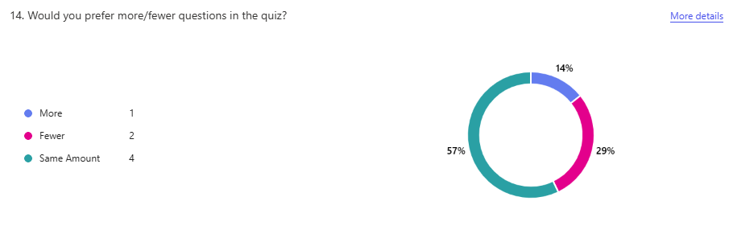

## Appendix 9: File Structure

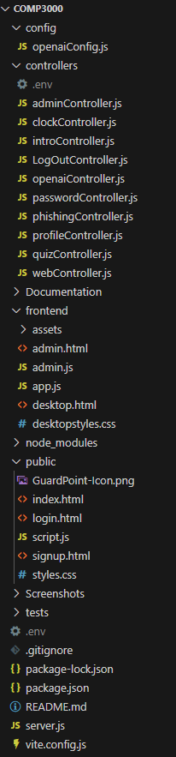

## Appendix 10: MVP Feature Table

|  |  |
| --- | --- |
| **MVP Requirements** | |
| **Feature** | **Achieved?** |
| Sign Up and Log in System | Yes |
| A virtual Desktop Feel with toggle functionality | Yes |
| One Task successfully integrated - Phishing Identification Task Displays example emails with tick box to select phishing type. | Yes |
| Once a task is complete the database is updated – meaning user can log out without losing progress. | Yes |
| Quiz with basic Question | Yes |
| Admin Login to view organisation average | yes |

## Appendix 11: Feature Table

|  |  |
| --- | --- |
| **Feature** | **Type** |
| Sign Up and Log in System | MVP |
| A virtual Desktop Feel with toggle functionality | MVP |
| One Task successfully integrated - Phishing Identification Task Displays example emails with tick box to select phishing type. | MVP |
| Once a task is complete the database is updated – meaning user can log out without losing progress. | MVP |
| Quiz with basic Question | MVP |
| Admin Login to view organisation average | MVP |
| Sign Up Parameters | Core |
| Reset task(s) | Core |
| Web Task Integration | Core |
| Password Task Integration | Core |
| Desktop Introduction | Core |
| Web Introduction | Core |
| Password Introduction | Core |
| Phishing Introduction | Core |
| Web Gamified Activity | Core |
| Privacy Policy | Additional |
| Terms and Conditions | Additional |
| ‘Have I Been pwned’ API integration | Additional |
| OpenAI Email Generation | Additional |
| OpenAI Web Generation | Additional |
| Quiz Pie Chart Results | Additional |
| Admin Dashboard Bar Chart | Additional |
| Admin Dashboard Pie Chart | Additional |
| Admin Dashboard Reset individual user tasks/quiz | Additional |
| Email inbox highlight words functionality | Additional |
| Quiz Reset | Additional |
| Quiz Scores sent to database and displayed in admin dashboard | Additional |
| Quiz Progress Bar and Question Number | Additional |
| Edit profile information | Additional |
| Delete Profile | Additional |
| End Cards per Task | Additional |

## Appendix 12: ISO 27002 Task Alignment

|  |  |  |
| --- | --- | --- |
| **ISO/IEC 27002 Control** | **Control Title** | **Task alignment with ISO 27002 Controls** |
| 6.3 | Information security awareness, education and training | GuardPoint provides interactive and engaging training on phishing, password safety and safe web browsing. This includes real time feedback per task, final quiz and an admin dashboard to track progress – ultimately helping organisations meet training and awareness requirements under ISO 27001. |
| 5.17 | Authentication information | The password task, aligning with NCSC guidance, promotes strong password practices and help users understand authentication risks – directly supporting secure management of authentication data. |
| 8.23 | Web filtering | Users are educated on recognising suspicious links and unsafe websites with the safe web browsing task. Therefore, user judgement is strengthened, and organisational web filtering policies are supported. |
| 5.2 | Information security roles and responsibilities | GuardPoint’s admin dashboard allows admins to track user progress, reset tasks, and monitor results - ensuring clear responsibilities for security awareness and training. Therefore, aligning with ISO’s requirement for managing security roles and responsibilities. |

## Appendix 13: ISO 27000 Series GuardPoint Compliance

|  |  |  |
| --- | --- | --- |
| **ISO/IEC 27002 Control** | **Control Title** | **How GuardPoint aligns itself** |
| 5.10 | Acceptable use of information and other associated assets | GuardPoint supports acceptable use by implementing a clear privacy policy and allowing users to manage their personal data. Users can edit account information and delete their account. |
| 5.18 | Access rights | GuardPoint enforces role-based access with separate interfaces for admins and users. Admins can only view users in their organisation, ensuring controlled access to user data. A logged in user only has access to their data. |

## Appendix 14: Risk Assessment

|  |  |  |  |  |  |  |  |  |  |  |  |
| --- | --- | --- | --- | --- | --- | --- | --- | --- | --- | --- | --- |
| **Assessment Date** | | | | 15/04/2025 | | | | | | | |
| **Assessor** | | | | David Penfold | | | | | | | |
| **Version No.** | | | | .001 | | | | | | | |
| **Signature of Assessor** | | | |  | | | | | | | |
| **Risk Score Matrix** | | | | | | | | **Risk Score and Description** | | | |
| **Severity** | | | | | | | | **Risk Score** | **Risk Level** | **Category** | **Description** |
| **Likelihood** |  | Insignificant | Minor | | Moderate | Major | Fatal |
| Very Unlikely | 1  Green | 2  Green | | 3  Green | 4  Green | 5  Amber | 1-4 | Low | Acceptable | No further actions needed |
| Unlikely | 2  Green | 4  Green | | 6  Amber | 8  Amber | 10  Red | 5-9 | Medium | Tolerable/Adequate | Should be reviewed to ensure that there is nothing else that can be done |
| Possible | 3  Green | 6  Amber | | 9  Amber | 12  Red | 15  Red | 10-15 | High | Undesirable | Immediately review current control measures, and where appropriate decide on further actions |
| Likely | 4  Green | 8  Amber | | 12  Red | 16  Red | 20  Red | 16-25 | Very High | Unacceptable | Stop activity and make immediate improvements |
| Almost Certain | 5  Amber | 10  Red | | 15  Red | 20  Red | 25  Red | **Likelihood (L) x Severity (S) = Risk Score (RS)** | | | |

|  |  |  |  |  |  |  |  |  |
| --- | --- | --- | --- | --- | --- | --- | --- | --- |
| **Risk Identification** | **What is being done to control the risk already?** | **Risk Score** with current controls in place | | | **What further action is necessary?**  *Only necessary if risk is level is high or above.* | **Target Risk Score**  Likelihood x Severity = Risk Score | | |
| **L** | **S** | **RS** |  | **L** | **S** | **RS** |
| Time Management Creep | Sprint Planning in place every 2 weeks and defined deadline in place. | 3 | 4 | 12 | Review workload against remaining time weekly and add buffer time before deadline. | 2 | 3 | 6 |
| Scope Creep | Predefined MVP. | 3 | 4 | 12 | Adjust Gannt Chart to align with any changes in the scope. | 3 | 2 | 6 |
| Incorrect User Redirect (sends user to admin dashboard) | Redirect based on user role. Automatically give all new users the role of ‘user’. Avoid leaving role blank. | 1 | 4 | 4 |  |  |  |  |
| Poor Project Flow | Added directional arrows, intro cards to desktop and intro cards to each task. Review feedback based on user testing and continuous feedback when the project is live. | 2 | 4 | 8 |  |  |  |  |
| Too complex tasks | Introduction cards provided and walkthrough on necessary tasks (Phishing identification). | 2 | 3 | 6 |  |  |  |  |
| Poor UI Design | Applied design principles when prototyping. | 3 | 5 | 15 | Refine desktop and tasks with more interactive elements that simulate a real desktop. | 3 | 3 | 9 |
| Outdated AI | Currently using most up to date OpenAI Version available. | 4 | 1 | 4 |  |  |  |  |
| No Privacy Policy/ Legal Coverage | Privacy Policy and Terms and Conditions present on sign up page. | 1 | 4 | 4 |  |  |  |  |
| Admin Dashboard displays incorrect users | Displays users based on the admin’s organisation. | 1 | 5 | 5 |  |  |  |  |